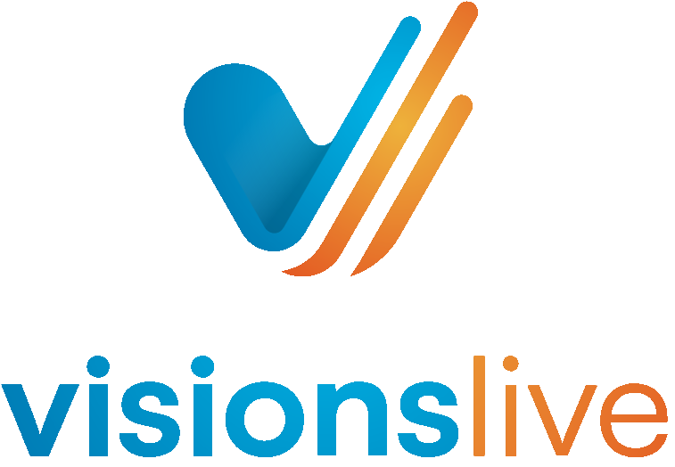

New Focus Groups- Respondent Guide

Prepared for:

Users of VisionsLive New Focus Groups and Interviews

1. Please look out for the session link which is usually embedded within an email from

@visionslive.com. Instructions on when and how to join the session will also be included within this email. Please complete your system checks if you have received a system test link and please click on your session link 15 minutes before the session begins.

1. Once you have clicked on your session link you will be brought through to a waiting room where a member of the VL admin team will carry out your tech checks. Please ensure that you have a working camera and microphone for the session and please disable any firewalls or VPNs for the session. To ensure your connection is up to speed for the session, please lose any other apps or tabs you may have open and connect with a reliable Wi-Fi or ethernet connection.

1. Below is a device compatibility grid if you would like to check which browser is most suited for your device:

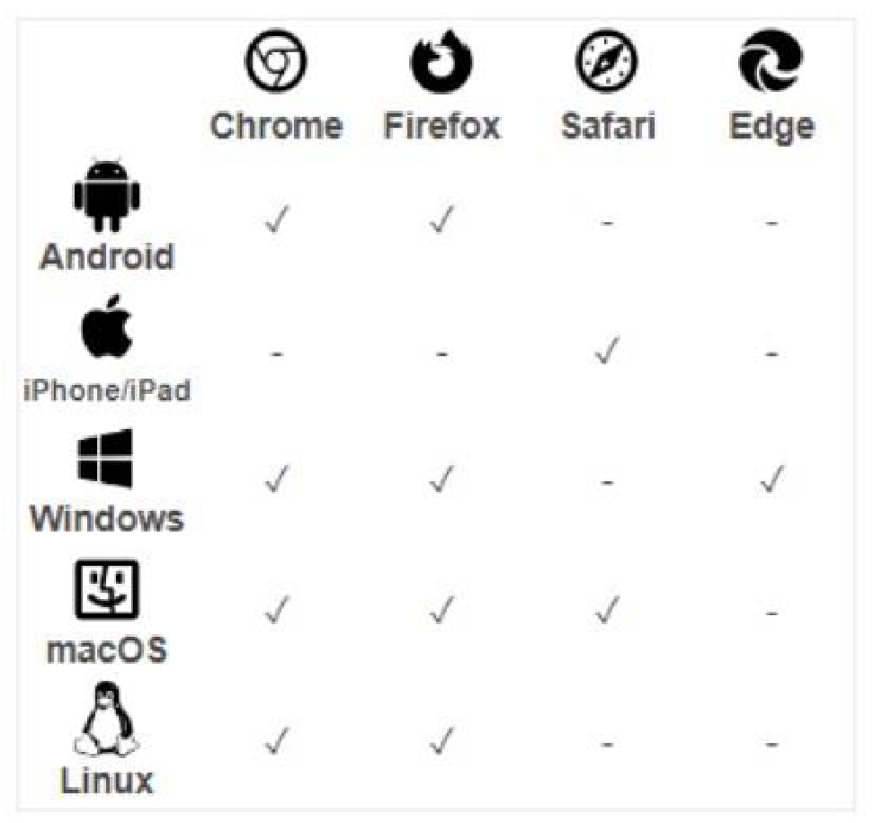

1. If you would like any additional information on how to prepare your equipment for the session, please contact your moderator.

1. Within the session room there are multiple ways you can communicate with your moderator. The first method is by using the respondent chat box. To use this, simply click on the chat box in the top right corner. You can view any messages from tech support and your moderato here.

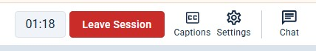

You can pin this chat open by clicking on the pin button. If you would like the close the chat simply click on an ear of the room outside of the chat area.

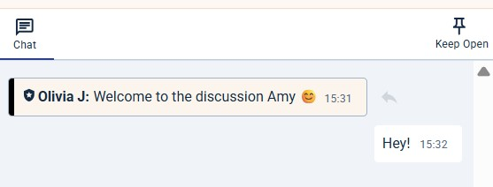

1. Messages in this area can be seen by all the moderators and observers within the session as well as any translators on the line, VL admin (tech support) and other respondents within the session.

1. You can also speak with the moderator by unmuting yourself and speaking into your microphone. You can unmute yourself by clicking on the microphone button shown on your camera tile.

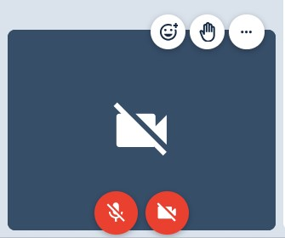

1. Next to this, there is a camera icon to able/disable your camera.

1. Also on your camera tile, there is the emoji icon that allows you to add reactions to certain parts of the session. To do this, click on the icon and select which reaction you wish to leave. Also, there is a hand icon that allows you to raise your hand to let the moderator know you have something to add. Once you have finished, click on the hand again to lower your hand.

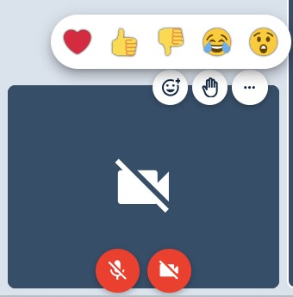

If you would like to blur your background, click on the 3 dots and choose ‘blur background’.

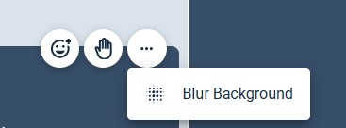

1. To answer a poll, please choose one option for a single select poll or multiple for a multi select poll and then click ‘submit’.

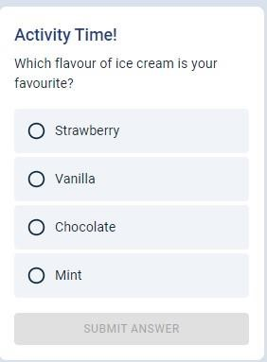

1. If you are asked to complete a heatmap activity, you must click on a part of the image and leave a reaction and comment, or you will have to highlight parts of the image and leave a comment. The highlight will change colour depending on the reaction you leave. Once you have written your comment, click submit and it will leave the comment and allow you to add more pins or highlights.

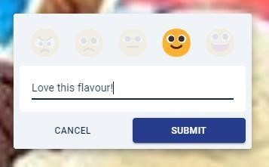

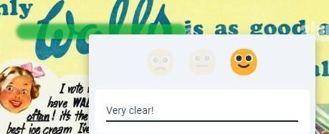

1. If a moderator has uploaded a collection, this gives you the opportunity to scroll through a collection of images in your own time. You do this by clicking on the arrows to move through the images. Each image is named to you know which is which and you can see all the images at the bottom and click on the image you want to see as well.

