

**Moderating a**

**Live Focus Group or Interview**

Prepared for:

Users of VisionsLive New Focus Groups and Interviews

Version: 1.1 happy to help. If you have any questions or issues, contact support@visionslive.com Last Updated: 08/04/24 and a member of our team will be

***How to use this handbook:***

This guide details how to moderate a live focus group or in-depth interview on VisionsLive from start to finish.

If you need information on something specific, you can find it using the table of contents below or by using CTRL+F to search for specific keywords.

# Table of Contents

Getting Started & Logging in

........................................................................................................................................ 3

The Session Room

................................................................................................................................................................ 3 The

Waiting Room

.......................................................................................................................................................... 3 Starting the session ........................................................................................................................................................ 5

Recordings and Transcripts

....................................................................................................................................... 5 Participants List ................................................................................................................................................................. 6

Chat Areas

............................................................................................................................................................................. 6

Screensharing

......................................................................................................................................................................... 9

Stimulus and Activities

.................................................................................................................................................... 10

Sharing Text or Image Stimulus ........................................................................................................................... 10

Running Interactive Activities

......................................................................................................................................11 Poll Activities .......................................................................................................................................................................11

Heatmap Activities

......................................................................................................................................................... 12

Text Prompt Activities ..................................................................................................................................................

12

# Getting Started & Logging in

When moderating an interview or group on the VisionsLive platform, there are two ways to get started: either clicking on the link to enter directly (this will have been sent to you via email) or logging in to the platform directly.

To log in, visit [https://portalapp.visionslive.com –](https://portalapp.visionslive.com/) you should have received an email regarding setting up your login details when you were added to the platform. If you haven’t, please contact support@visionslive.com.

If you have forgotten your password, or are yet to set one, click on ‘Forgotten your password?’ to be sent a reset link.

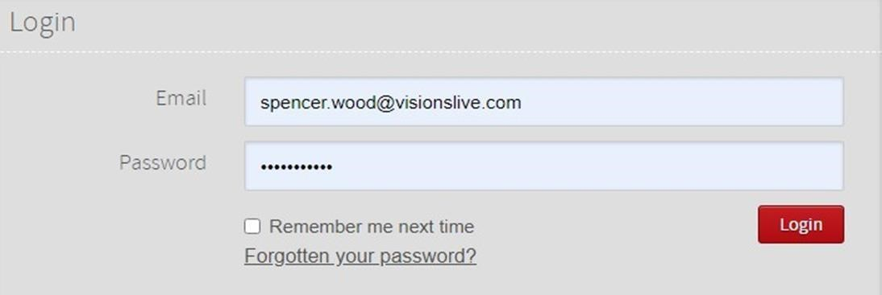

Once logged in, you will be taken to your company’s project dashboard. Here you will see a list of your projects, with the newest at the top and the oldest at the bottom.

Click on the project your upcoming session is taking place in, and then click on the interview or group at the top of the page – this will be the one starting next.

This will bring you to the session’s dashboard. You can then click the blue ‘Enter Session’ button to enter the session room.

# The Session Room

When you first enter a live session room, the cameras of all other respondents or moderators are shown in the centre of the page. Your own camera tile will be shown in the bottom-right of the page.

**Note:** If you enter the session room earlier than 15-minutes before it is due to start, your camera and microphone will not activate.

## The Waiting Room

When a respondent or observer clicks on their link to join the session, they will first enter the Waiting Room. This is available as early as 15 minutes before the session’s scheduled start time.

All interviews and focus groups will have a member of the VisionsLive tech support team assigned automatically, and they will handle the waiting room process for you by default.

If you would prefer, you can do this process yourself following the instructions below. Please ensure you let us know about this ahead of time to avoid confusion.

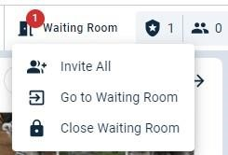A red notification will pop up on this button whenever there is at least one respondent or observer present in the waiting room.

As the moderator, you can enter the Waiting Room by clicking on the ‘Waiting Room’ button in the top left corner of the actual session room and then clicking ‘Go To Waiting Room’.

When you enter the waiting room, you can use this area to speak to and filter through respondents prior to the group commencing.

There is a chat space on the right-hand side which you can use to send messages to the group as they wait. If a respondent replies to this message, it will be private from the rest of the group.

You can also click on an individual’s ‘Messages’ tab to send them a message privately. If you do this and would later like to return to the group chat, click on the ‘Chat To All Respondents’ tab in the top right corner.

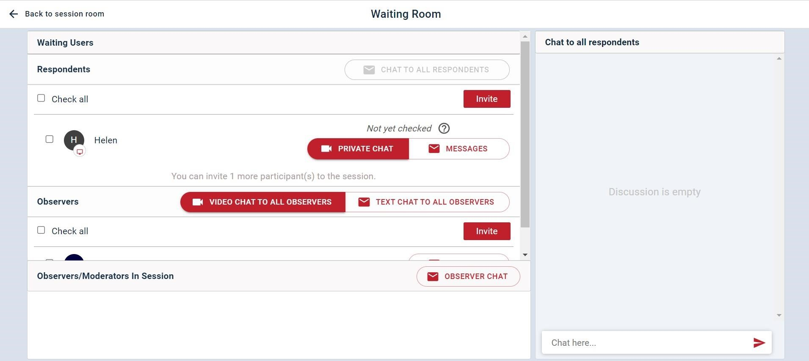

Clicking on the ‘Private Chat’ feature for a specific respondent will open a 1-to-1 video chat with them – this allows the moderator to do a tech check with the respondent so you can make sure you can both hear and see each other prior to the group beginning.

Upon completion of the check, in the top right corner you should mark this respondent as ‘Ready’ or ‘Not Ready’ to return to the waiting room.

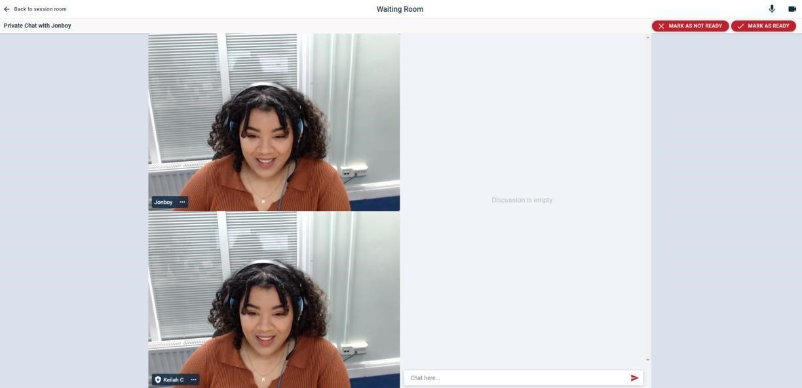

In addition to handling the waiting room, the VisionsLive tech support team member who is assigned to your session will handle inviting respondents into the main room for you.

If you would prefer, you can do this yourself following the steps below, but please ensure you let us know you will be doing this ahead of time to avoid confusion.

To invite select participants into the main session room, click on the check boxes next to their names in the waiting room, and then press ‘Invite’.

Alternatively, if you are ready for all respondents to join, click ‘Back to the session room’, click on the ‘Waiting Room’ button and then hit ‘Invite All’.

Once at least one respondent has been invited into the main session room, a timer and an ‘End Session’ button will appear on the top-right of the page to let you know that your session has officially started, and your usage has begun.

Inviting observers in early does not set off your usage timer, so you are welcome to admit them before respondents.

Once the session has started, observers will be automatically admitted to the group without needing to invite them from the waiting room, however respondents will still go to the waiting room.

If needed, you can also choose to close the waiting room after the session as begun, using the corresponding button when selecting ‘Waiting Room’ on the top toolbar. This avoids latecomers sitting in the waiting room if it is too late to join. You can add a custom message that tells them they are too late, and any additional instructions if appropriate.

## Recordings and Transcripts

Video recordings are generated automatically when the usage timer begins, and in addition, your tech support team member will be doing a manual recording in the background to ensure there is a backup. Therefore, you do not have to do your own recordings.

To check whether AI-generated transcripts are enabled, look for a ‘CC’ icon on the top-right, next to the ‘cog’ icon that represents the settings menu.

If that icon isn’t there, click on the cog, then ‘Session Settings’, and toggle ‘Enable real-time voice transcriptions’ to ‘On’. Live transcripts cost an additional fee, so it will confirm you are happy with that. Then, click ‘Save’ and they will be enabled.

We are not able to generate voice transcripts within the platform after the session has taken place, so if you have any doubts or issues, please ask your tech support team member for assistance.

## Participants List

You can get a quick overview of how many participants are in your session by looking at the icons on the left of the top toolbar of the session room, next to the ‘Waiting Room’ button.

From left to right, the icons represent: moderators, respondents, observers, conference callers.

To get a more comprehensive list of who is in your session, you can click the ‘Show Participants List’ button on the far-right of the toolbar, represented by the icon of two people.

This list shows the names of all Moderators, Respondents, and Observers who have been in the session room at any point.

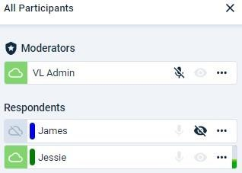Anyone that is currently in the room will have a green cloud icon next to their name. Anyone who has left the session, or temporarily dropped out, will have an icon with a grey cloud and a line through it.

The microphone icon allow you to see who is muted, or manually mute them.

The eye icon allows you to hide someone’s camera tile from view of all participants in the session e.g. you can hide someone who joins the group as a moderator but isn’t joining the discussion.

## Chat Areas

The chat area is situated at the right of your screen and can be viewed by clicking on the text box icon in the top

right-hand corner. 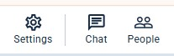

By default, this will open 3 chat panels: the observer chat, and the respondent chat and ‘other’. You can pin the chat area open by clicking on the ‘keep open’ button.

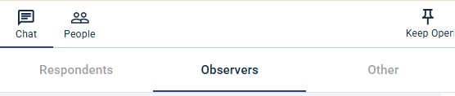

### Observer Chat

The Observer Chat is where observers and moderators can talk to each other throughout the session. This chat is private and cannot be seen by respondents.

This panel also notifies moderators when observers join or leave the waiting room before the session, or the session room once it has started.

The messages sent by moderators have a gold hue to them for easy identification.

### Respondent Chat

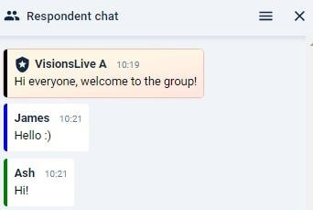The respondent chat is where respondents can message each other and the moderator(s).

Observers cannot type in this chat but can read it.

Like the Observer Chat, this chat area indicates when respondents enter the waiting room, are invited to the session from the waiting room and when they leave.

The Respondent Chat also includes the unique colours and names of each participant alongside their messages.

### Other

In this area, moderators can create group chats and view private messages.

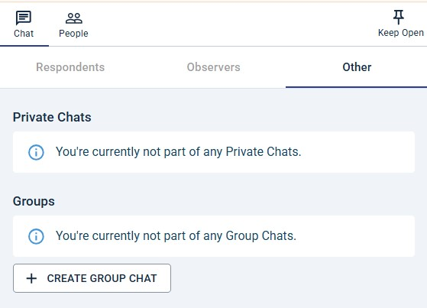

### Private Chats

Moderators can create private chats with any participant in the session room. To do this, click on the three dots next to a person’s name on their camera tile or in the ‘Show Participants List’ section and select “Private Message”. The new chat can be found in the ‘Other’ panel.

### Group Chats

You can also create group chats between yourself and any participants. This includes VL Admin, and the translator. This is done by “Create Group Chat”.

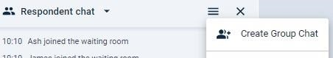

Note: Anyone can be added to a group chat, but observers and respondents cannot be added to the same chat as each other to avoid

The group chat will need to be titled before adding the participants to create it.

### Moving between chats

It is easy to move between chats. Simply click on the chat heading you wish to move to. To close a chat, click outside of the chat area and into the main session room. You can pin a chat open by clicking on ‘keep open’.

### Notifications

A notification in the form of a jumping red circle will be shown on top of the textbox at the top right corner of the screen when there are any new messages or notifications in the chat areas. The circle has a number indicating the number of new messages.

Clicking the icon will open the chat panels where the new messages will be shown. If the chat panels with the new messages are hidden from view but the chat area is open, the notification will be in the form of a red flashing circle at the top of each chat panel. Clicking that circle will show the name of the chat and the number of unread messages.

### Chat Tools

The chat areas include a range of useful tools found at the bottom of each panel.

* **Text box:** Type messages to other participants by typing in the “Chat here…” space.
* **Emojis:** To the right of the space, there is a smiley face denoting some easy access emojis that can be used by all participants.
* **Attachments:** Moderators can send attachments using the paperclip symbol, however observers and respondents do not have this option.

In addition, the speech bubble icon at the bottom right of the panels allows moderators to create and select **‘Predefined Probes’**. These act like keyboard shortcuts made in advance of a session for efficient messaging.

Predefined probes must be made by each individual moderator, i.e. they cannot be set up on your behalf, but they can be done ahead of time, and when they are done once, they are saved for all upcoming sessions.

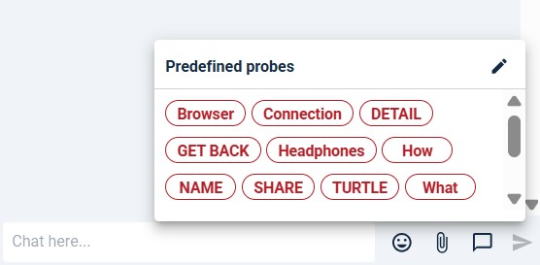

To create new probes, click on the pencil icon (shown above) and add your probe to the textbox with the formula ‘probe name’ = ‘full length text’

For example, a probe could be set up as follows: “HAYA = How are you all?”. You would then select the probe from the drop box and send the full text.

# Screensharing

Screensharing allows you to share your browser page or device window with your session participants.

To do so, click the right-most icon at the bottom of your camera tile (laptop icon with an arrow).

Depending on your browser, the pop-up that shows will have different wording, but generally it will ask you whether you would like to share your browser tab, your window, or your entire screen.

When you share your screen, there will be a preview of the screen you’re sharing on the top-left of the platform.

If you share your browser tab or window on a second screen, you can view the platform and the tab you are sharing at the same time.

We recommend avoiding sharing your entire screen where possible so that you do not show your respondents the platform, any observer chat, or device notifications accidentally.

When you are finished sharing your screen, click the red ‘End Screen Sharing’ button that is underneath the screenshare preview.

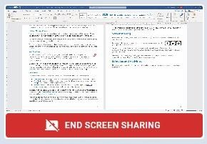

# Stimulus and Activities

The platform allows stimulus and activities to be pre-loaded into a session room to aid your discussion.

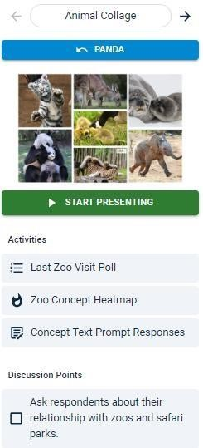If you have these in your session, you can find them in a slide deck on the top-left of the screen.

There are arrows that you can click through to see each piece of text or image stimulus that has been added to the session, with any associated activities or discussion points below them.

## Sharing Text or Image Stimulus

To show a piece of stimulus to your respondents, move through the slides to the item you’d like to show and click the green ‘Start Presenting’ button.

This will then show the stimulus at full size to the respondents, but your view as a moderator will keep respondent cameras as filling the screen.

When you click to present a slide, the green button will turn red and allow you to ‘Stop Presenting’ if you would like to hide the stimulus.

If you would like to change the slide, simply click the arrows to move to the next piece of stimulus and click ‘Start Presenting’ again. This will override any currently presenting stimulus if the previous one wasn’t hidden.

Clicking through the slide deck does not automatically show the stimulus to the respondents, so you can look through these at any point during a live group or interview.

**Note:** If you are presenting a piece of stimulus and then use the arrows to view a different slide, a blue button with the title of the

slide currently being presented will appear. Clicking this will quickly bring you back to the active stimulus.

### Discussion Points

Discussion points can be pre-loaded into the platform to allow you to have on-screen prompts and ensure you have covered everything for a piece of stimulus.

These will be listed below a piece of stimulus and its associated activities, with a tick box.

Once you have covered a discussion point, you can select the tick box to cross it off the list of items to cover.

# Running Interactive Activities

If interactive activities were set up in your session, you will see an ‘Activities’ section under the stimulus preview when going through the slides.

These could be Polls, Heatmaps, Text Prompt activities, or a combination of the three.

These may have been individually named during the session set up, but you will also be able to tell which activity type each one is by looking at the icon to the left of the title (see the image on the previous page for examples).

Whilst running these, you will be able to see the activity in the centre of the screen, and the respondent cameras on the right-hand side of the screen.

## Poll Activities

To run a poll activity, select it from the list and it will bring up the Poll panel. This gives you a preview of the poll prompt, and the options. At this point, the respondents cannot see the poll.

If you need any part of the poll changing at this point, you can either do so yourself in the ‘Edit Stimulus’ section, or you can ask your tech support team member to do so for you in the chat areas.

If you are happy to begin, select the ‘Start Activity’ button to show the poll to the respondents and allow them to complete the activity.

The activity that is currently running will turn green on the ‘Activities’ list, and it will have a timer to let you know how long that activity has been running.

You will see responses in real time as they come in and can use the panel at the side to see who has answered (represented with a tick icon), and who you are still waiting for (represented with a timer icon).

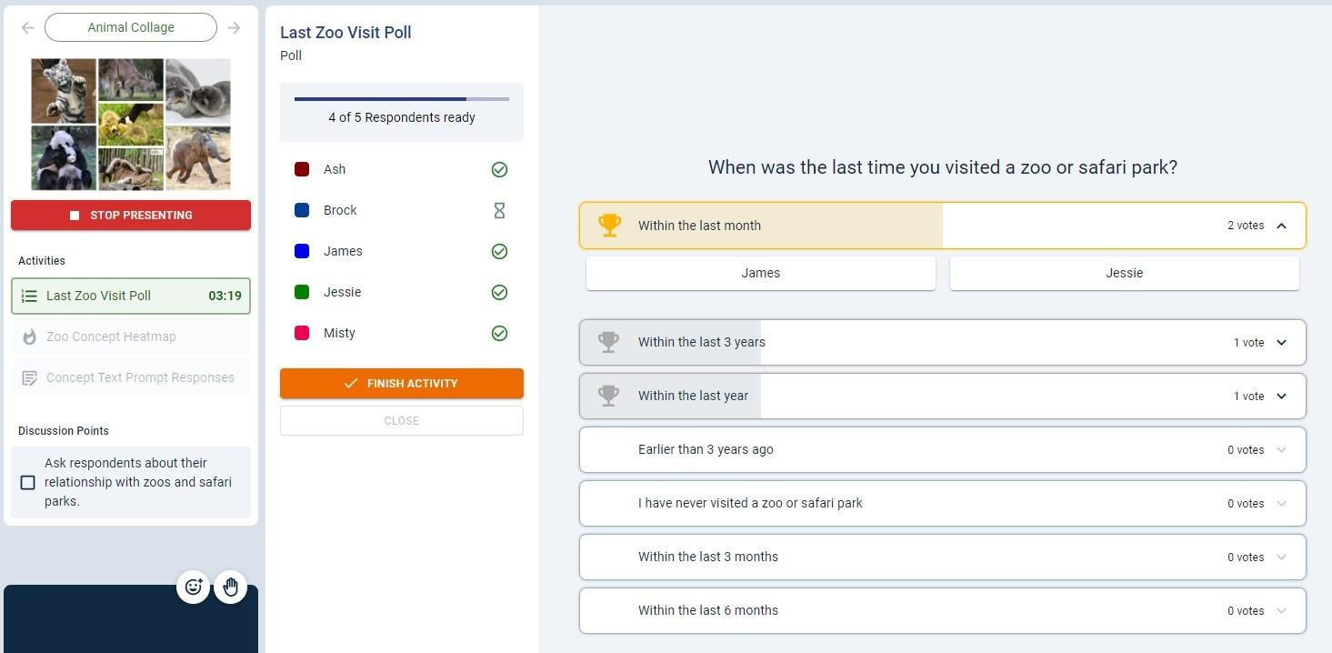

In the centre of the screen, you will see a dynamic list of responses – when votes come in, options with the highest number of votes will be at the top, and the lowest will be at the bottom. In addition, the first-place response will have a gold trophy and outline, secondplace will have silver, and third-place will have bronze.

If you click on a specific option, you will be able to see the names of the respondents who chose that option.

To end the activity, click the orange ‘Finish Activity’ button.

**Note:** Polls cannot be rerun when you end the activity, so please ensure everyone has submitted their answers before ending.

## Heatmap Activities

To run a heatmap activity, select it from the list and it will bring up the Heatmap panel. This gives you a chance to preview the heatmap prompt, and if you hover over the words ‘Sentiment Guide’, you can see the sentiment options available to the respondents. These will be pre-selected emojis with a title. At this point, the respondents cannot see the heatmap.

If you need any part of the heatmap changing at this point, you can either do so yourself in the ‘Edit Stimulus’ section, or you can ask your tech support team member to do so for you in the chat areas.

If you are happy to begin, select the ‘Start Activity’ button to show the poll to the respondents and allow them to complete the activity.

The activity that is currently running will turn green on the ‘Activities’ list, and it will have a timer to let you know how long that activity has been running.

Once responses start to come in, you will see the sentiment markings in real time. You can hover over them to see who left them, and their additional comments if there are any. In addition, the sentiment marking will have an outline that matches the respondent’s unique colours.

You can use the panel at the side to see who has submitted that they are finished with the activity (represented with a tick icon), and who you are still waiting for (represented with a timer icon).

To end the activity, click the orange ‘Finish Activity’ button.

**Note:** Polls cannot be rerun when you end the activity, so please ensure everyone has submitted their answers before ending.

## Text Prompt Activities

To run a text prompt activity, select it from the list and it will bring up the Text Prompt panel. This gives you a chance to preview the text prompt or question before running it. At this point, the respondents cannot see the prompt.

If you need any part of the prompt changing at this point, you can either do so yourself in the ‘Edit Stimulus’ section, or you can ask your tech support team member to do so for you in the chat areas.

If you are happy to begin, select the ‘Start Activity’ button to allow the respondents to complete the activity.

Once responses start to come in, you will see them come up in the middle of your screen in real-time, along with the names of who submitted them.

You can use the panel at the side to see who has submitted their answers (represented with a tick icon), and who you are still waiting for (represented with a timer icon).

To end the activity, click the orange ‘Finish Activity’ button.

**Note:** Polls cannot be rerun when you end the activity, so please ensure everyone has submitted their answers before ending.

# Ending a session

There are now two options for ending a session, and it’s important to choose the one that suits your needs:

1. To end the session for everyone on the call: Click on *‘End Session’*, then click *‘End Session’* again. This will remove all participants from the session and stop any further charges for the session.
2. To end the session for respondents while still speaking with your observers: Click on *‘End Session’* and then check the box that says, *‘Start an Observer Wrap-Up’*. After that, click *‘End Session’*. This will activate the Observer Debrief Channel for all moderators and observers.

o The Observer Debrief is free of charge. o Microphones are enabled for the observers, allowing them to speak directly with the moderators. o The chat area is available, and moderators can also share their screen.

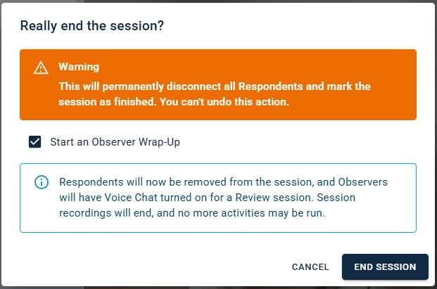

To end the debrief session, click *‘End wrap-up’*. Only moderators can end the debrief. Observers can leave the debrief at any time by clicking the red *‘Leave’* button on the righthand side.

Important: Ending a session is irreversible. Clicking *‘End Session’* will close the session for everyone. If a moderator wishes to leave the session before the scheduled end time, they should click the red *‘X’* in their browser to close the page. Another thing to mention is that the timer keeps running in the wrap up session and the extra time can be seen to the right-hand side of the ‘+’ as seen below.

