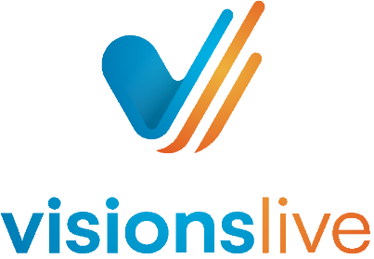

# An Observer’s Guide - New Focus Groups and

# Interviews

Prepared for: Users of VisionsLive New Focus Groups and Interviews

## Accessing a session

You will receive a session link via email, typically from an address ending in

@visionslive.com. Please check your inbox (and spam folder) for this invitation.

Alternatively, you may have received a project-wide link that grants access to all sessions

within the project. To join, simply click the link and enter your name. If multiple sessions are

running concurrently, you'll be prompted to select the specific session you'd like to enter.

If you haven't received your link or need assistance, please contact your project manager or

reach out to our support team at [support@visionslive.com](mailto:support@visionslive.com)

## The waiting room

After clicking the provided link, you'll enter the observer waiting room. Once the

respondent is ready, you'll be admitted to the main session.

If you've requested early access for a technical check, our support team will bring you in as

soon as possible. Please note that they may be assisting another participant at that

moment. Your patience is greatly appreciated.

## The session room

Once the VisionsLive administrator admits you into the session, you'll have the opportunity

to select your preferred language. This choice will adjust the platform's interface (UI) to

display in your selected language.

If you need to change your language preference later, you can do so by accessing the

language settings within the session settings located in the right corner of the session

room.

## Chat Functions in the Session Room

Within the session room, you have multiple options to communicate with your moderator:

### 1. Observer Chat Box

Located on the right-hand side of the portal, the Observer Chat Box allows you to send

messages visible to all moderators, observers, translators, and VisionsLive technical

support. To use this feature:

* Click on the chat bubble icon.
* Type your message into the chat box.
* Press the arrow button to send.
* To minimize the chat window, click outside of the chat area.
* If you would like to pin the chat area open, click on the pin icon.

### 2. Private Chat with a Moderator

For confidential communication, you can initiate a private chat with a moderator:

* Click on the ‘People’ button located at the top right of the screen.
* A window will appear displaying all available moderators in the session.
* Click on the ellipsis (three dots) next to the moderator's name and select ‘Private Chat’.

Once initiated, the private chat will replace the Observer Chat in the chat area. You can

switch between chats using the drop-down arrows within the chat interface.

## The observers view

As an observer, you will not have camera or microphone functionality and will remain

hidden from respondents throughout the session.

Upon entering the session room, your default view will display the respondent and

moderator centred on the main stage. If stimulus materials are being utilised, a preview will

appear to the left of the main stage.

Should stimulus materials be uploaded, you can interact with them by clicking through the

previews located in the stimulus deck. This allows you to explore different activities and

preview the questions being posed. To enlarge the stimulus for a closer view, click on the

double arrow icon situated in the top-right corner of the stimulus preview.

These features are designed to enhance your observational experience without disrupting

the session.

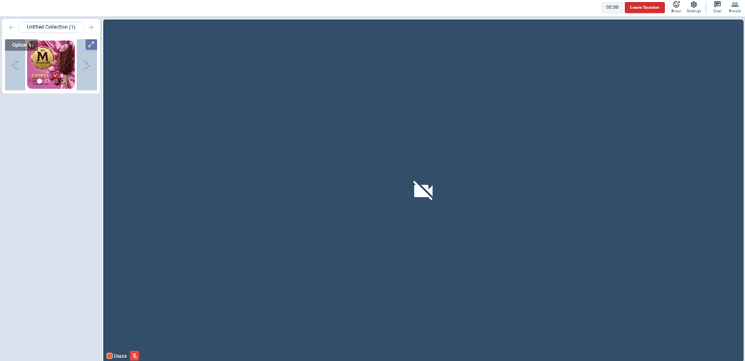

## Activities

As respondents engage in activities such as polls and heatmaps, observers receive a real-

time preview of their responses. Below is an example of what an observer sees while a

moderator conducts a poll. For heatmap activities, observers can hover over the pins or

highlighted areas to view individual responses as they appear. If the moderator has chosen

to anonymise the results, the observer will see responses without any identifying

information, the names of the respondents will not be visible.

## Submitting Reactions as an Observer

As an observer, you can provide real-time feedback during the session by submitting

reactions. These reactions are recorded and included in the session reports for moderators

to review.

To submit a reaction:

1. Navigate to the upper-right corner of the session room.

2. Click on the ‘React’ button.

3. Choose an emoji that best represents your feedback.

4. Add a note to provide additional context.

Reactions serve as a discreet way to highlight key moments or provide insights without

interrupting the flow of the session.

These reactions are compiled into the session's post-event reports, assisting moderators in

identifying significant moments and enhancing the overall analysis.



## Enabling and Customising Closed Captions

As an observer, you have the option to enable closed captions to read along during the session.

To enable closed captions:

1. Click the “CC” button located at the top right corner of the session room.

2. To disable captions, click the “CC” button again.

To change the caption language:

1. After enabling captions, click the cog icon (⚙️ ) at the bottom right of the caption

window.

2. Select your preferred language from the available options.

## Switching Between Original and Translated Audio Channels

VisionsLive offers dual audio channels to accommodate simultaneous translation during

sessions. Please note, not all sessions have a simultaneous translator on the line.

To switch between the original and translated audio channels:

1. Locate the “Original Audio” dropdown menu at the top-left corner of the session

room.

2. Click the dropdown to view available audio channels.

3. Select your preferred channel (e.g., "Translated Audio") to switch.

If you experience issues hearing the translator:

* Ensure you've selected the correct audio channel.
* Verify that your device's sound is enabled, and the volume is turned up.
* Check your browser settings to confirm that audio playback is allowed.

## Observer Wrap-Up Session

At the end of the main session, the moderator may initiate an Observer Wrap-Up, a private debrief exclusively for observers and moderators. This segment is not recorded, ensuring a confidential environment for open discussion.

During the Observer Wrap-Up, microphone access is granted to all observers, allowing for verbal interaction with fellow observers and the moderator. This is an opportunity to share immediate impressions, discuss key moments, and pose questions directly.

To exit the session at any time, simply click the red “Leave” button located at the top right corner of the session room.