

Creating and Content-Loading  
a Live Session

Prepared for:

Users of VisionsLive’s NEW Focus Groups and Interviews

##### How to use this handbook:

This guide details how to set up a live focus group or in-depth interview on VisionsLive from start to finish.

If you need information on something specific, you can find it using the table of contents below or by using CTRL+F to search for specific keywords.

**Table of Contents**

Logging in & Getting Started 3

Creating Groups or In-Depth Interviews 4

Setup Wizard Options 5

Session Dashboard 7

Editing Session Setup Settings 8

Extracting Participant Links 8

System Checks 10

Setting up the Session Room 10

Session Settings 10

Adding Stimulus 11

Uploading Image Slides 12

Uploading Text Slides 12

Uploading Collections…………………………………………………………………………………………………………………………………..13

Deleting a Slide 13

Changing the Slide Order 13

Adding Interactive Activities 13

Poll Activities 14

Ranking Poll Activities………………………………………………………………………………………………………………………………….14

Heatmap Activities 14

Text Prompt Activities 15

Activity Presentation Options 15

Templates 15

Saving a Template 15

Applying a Template 15

## Logging in & Getting Started

Log in at <https://portalapp.visionslive.com>– you should have received an email regarding setting up your login details when you were added to the platform. If you haven’t, please contact support@visionslive.com.

If you have forgotten your password, or are yet to set one, click on “Forgotten your password?” to be sent a reset link.

Once logged in, you will be taken to your company’s project dashboard. Here you will see a list of your projects, with the newest at the top and the oldest at the bottom.

To create a new project, click on the “New Project” button in the top right of the screen.

From here, enter your “Project Name” and “Client Name”. A description is not mandatory, and the language can be set at session-level if necessary, so does not need to be changed at this stage.

The “Sender Email Address” lets you know what email address your participants will get emails from if you send correspondence through the platform.

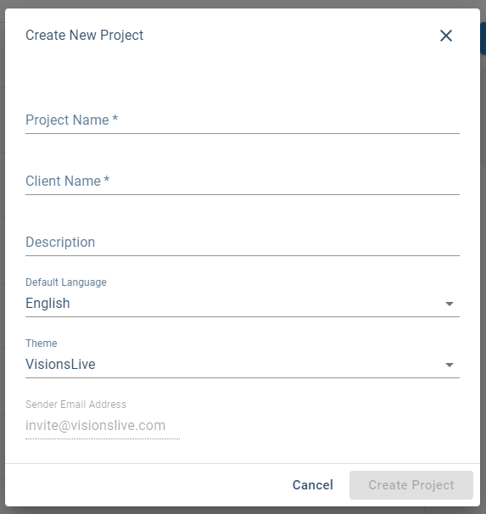

## Creating Groups or In-Depth Interviews

Enter a project by clicking on it on the project dashboard. This takes you through to the project’s activity dashboard, and will show all the activities (i.e., Focus Groups or Interviews) created within that project.

Click the “Create New Activity” button in the top right corner to begin setting up new activities.

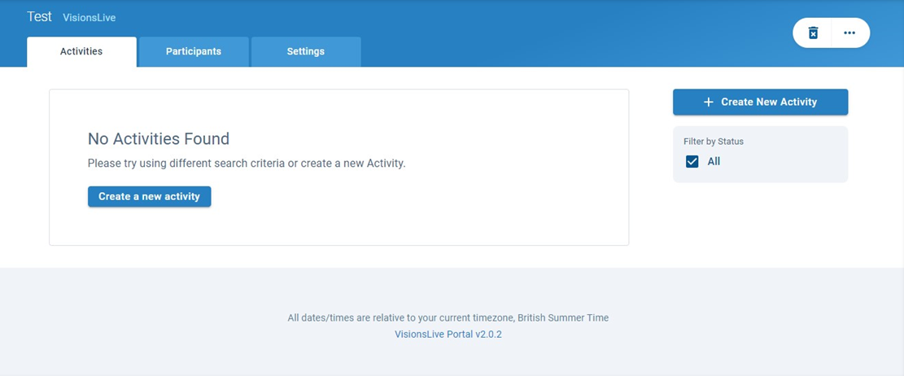

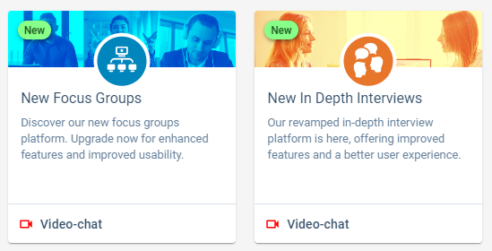This will open a setup wizard, starting with an activity select screen.

The NEW platform options can be found in the bottom-right.

Choose the **“Video-chat”** option under **“New Focus Group”** or **“New In Depth Interview”**.

The activity type cannot be changed after creation, so ensure you select the right one before moving forward.

Once selected, you can select the standard settings for your activity. There will also be small question mark icons  to provide you with information about specific settings as you move through.

**Note:** All settings (other than language) can be changed after creation. For example, if your fieldwork dates change, you can edit the session later without having to remake it from scratch. See ‘Editing Session Setup Settings’ for more information.

### Setup Wizard Options

There will be settings under the headers below.

##### Details

* **Language** – This dictates the default language setting within a session. This affects the language of the platform’s interface in the video recording, such as button text and platform prompts, and the default spoken language for transcriptions (this can be changed at the next stage).   
    
  Participants will be prompted to select the language they would each like to see the platform in when they join, rather than seeing the default language.
* **Server Location** – There are 5 servers to choose from – we recommend choosing the server closest to your respondents.
* **Template –** Useful if you are using the same content for several groups. When you’ve loaded content into your first activity you can save it as a template.   
    
  When creating your next group, you will find this template in the “Template” drop-down ready for you to select. This will copy the previously loaded content across to your new group, saving you the trouble of re-uploading it.For more information, see ‘Saving a Template’ and ‘Applying a Template’

##### Schedule

* **Start Date** – Ensure the time and date you have chosen corresponds correctly with the time-zone selected in the drop-down above it. The platform recognises when a time-zone has gone back or moved forward an hour.
* **Test Activity** – Tick this button to mark the activity as a test session, so you and your team can use a session room without a usage charge. Please inform the team and put the word ‘Test’ in the activity title when setting these up.  
    
  Please also note, VL Tech Support do not automatically join test sessions, so please let us know if you would like our assistance during your test.
* **Estimated Duration** – Drag the marker to adjust the time you expect a session will last. This is added to the invitations sent from the platform by default, however a session will only end when you choose to manually end it.

**Note:** Our usage pricing system is based on 15-minute blocks to ensure you are not over-paying for your true usage. We also allow a 3-minute grace period every 15 minutes, to allow you to say your goodbyes and close-down the session without rushing.

* **Spoken Language** – This is the language that will be spoken during the focus group and detected by the voice transcription service.
* **Voice Transcription Language** – The languages available to translate the voice transcriptions into. English and the spoken language will always be included.

##### Participants

* **Select Respondents** – If you have already added respondents to your project, there will be a list to select from on this page by selecting the tick boxes next to their names. If you have used groups/profile filtering information, you can use the ‘All Groups’ dropdown to filter through them.   
    
  If you haven’t, you can add them by clicking ‘Add Respondents’ and following the below:
* **Import from Excel** (adding in bulk) – Copy and paste the data with your respondent information, ensuring you include a field for first name and email address.   
  Last names, or last initials, are recommended to differentiate respondents, but are not compulsory. Custom fields may be included if you wish to view specific criteria about your respondents during the session.

All participants must be uploaded in batches dependent on their time-zone (this ensures that they are sent the correct time when sending their invitation).

**One at a time** – Fill in information per respondent. First name, email address, and time-zone are compulsory fields.   
  
Note: Dummy emails (e.g. emails that end in ‘@example.com’) can be used for confidentiality. When the activity is created, individual participation links can be extracted and sent externally.

**Note:** Respondent emails will be sent as soon as the session is confirmed at the final stage. Emails can be resent e.g. a reminder on the day, but if you do not want them sent at the time of the session creation, you can skip this step and come back to it.

* **Select Moderators** – Choose moderators to add to the session from a list of those previously added to this project. Select ‘Add moderators’ to add others who are on company account.   
    
  If your moderator has not been added to the company account, an account administrator will need to add them via the ‘Users’ section, found on the initial company dashboard.   
    
  Anyone who will need moderator access, including anyone who will be doing/reviewing the setup before the group but not moderating, will need to be added as a moderator.
* **Select Observers** – You can either add observers in the same way as respondents (above) to give them unique joining links, or alternatively when the session is created, you can extract one link that you can pass on to all observers at once (see ‘Extracting Participant Links’ section)

##### Email/SMS

* **Availability emails** – An optional email. If selected, sends respondents an initial email asking if they are available to join the group that is scheduled to take place.   
    
  If they answer “Yes” they will be sent an email invitation with their joining link; if they answer “No”, or do not respond, they will not be sent an email invitation.
* **Invitation Emails** – A required email. These start with a standard English template, that can be edited to suit your project. These have tags (e.g. {these}) that automatically pull information to add to your emails.   
    
  The {ActivityAccessLink} must remain in the template as this is the recipient’s link to join the session.   
    
  The {ActivityStartTime} tag is also very useful as this adds the start time of the session, adjusted to be specific to the time zone of that respondent.  
    
  The {SystemCheckLink} gives respondent a link to a 1–2-minute system check, where our server checks their internet connection is strong enough, that they are using a suitable device and OS, and that their camera and microphone are set up and working correctly.
* **SMS reminders** – An optional notification. Allows you to send a customisable reminder to the respondents via text message, between 15 minutes – 4 hours before the session is due to begin. There is a small charge per SMS.

## Session Dashboard

Once a focus group or interview is set up, you will have access to the session’s dashboard. This shows you when the session is due to start, who has been invited and the status of their tech checks, as well as the option to edit setup options and extract participant links.

The session dashboard shows you information about a session, including the date and time it begins, which participants are invited, and their System Check status.

### Editing Session Setup Settings

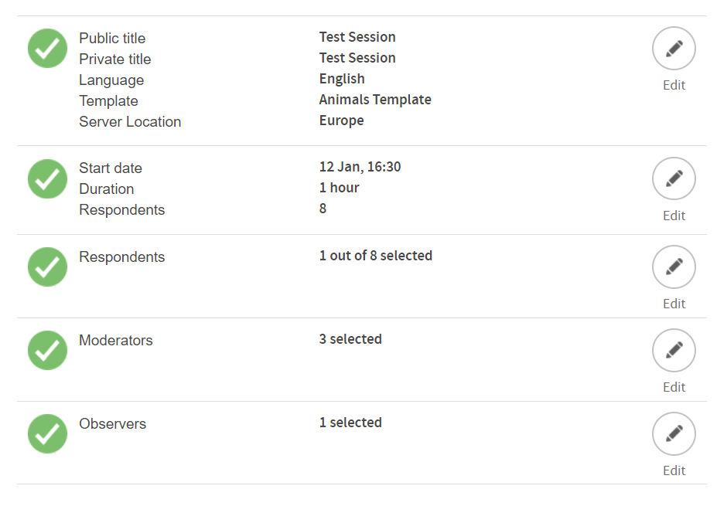If you need to edit any details after a session is created, you can do so by selecting the ‘Setup’ button on the lefthand side of the session dashboard.

This will bring you to a page that looks like the setup confirmation page, and will allow you to change different details by clicking the ‘edit’ button next to the appropriate section.

### Extracting Participant Links

If you need the links for participants in a session, e.g. if you used dummy email addresses during setup, you can access them by clicking on the ‘Links’ button on the left-hand side of the session dashboard.

This will bring up a page with links for every participant added during the setup stage. This includes respondents, observers, and moderators.

You can copy individual links for each participant or copy and paste the whole table.

Every link within the top three sections is unique to that user – ensure that if they are shared outside of the platform, the name at the end of the link matches the user you are sending it to. If two users have the same link, they will kick each other out when trying to join to session.

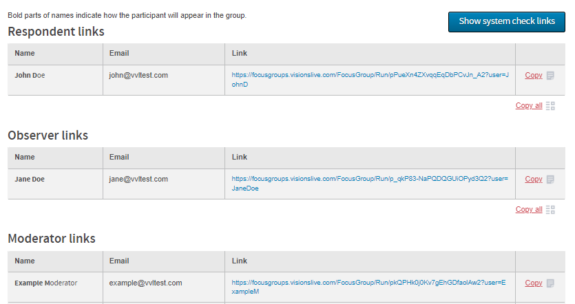

**Note:** If you change the settings of a session, e.g. the time is rescheduled, this will not change the links.

Below the regular participant links, there are additional links that are automatically generated for every created session: a translator link, and registration links.

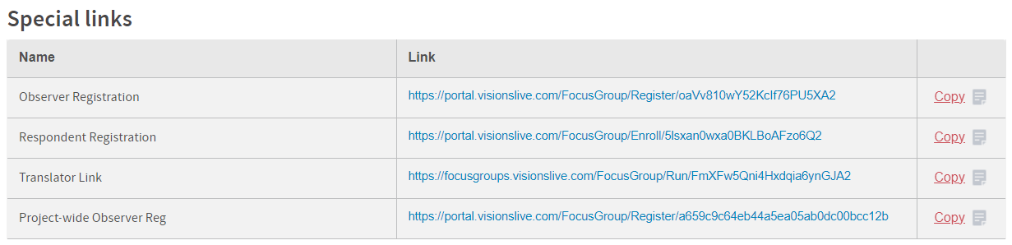

**Translator Link –** As no email address is required to create a translator link, if you have a simultaneous translator joining your interview, you will need to get their link from this page and send it to them outside of the platform. Only one person can use this link at a time.

**Observer Registration Link –** If you don’t want to add your observer email addresses to the platform individually, you can use an observer registration link. This gives you one link that you can send to all your observers that allows them to join the session you have selected. They will be prompted to choose their own name when they join.

**Project-Wide Observer Registration Link –** Similar to the observer registration link in that you can send the same link to all observers, but this option allows you to send one link that lets observers join any upcoming session within the project, not just the one that you currently have selected.

This is our most recommended method of inviting observers to view sessions.

### System Checks

Respondents can be sent a System Check in their invitation. This System Check allows them to check whether their camera, microphone, and internet are compatible. This can help respondents to solve any tech issues before the session’s start time.

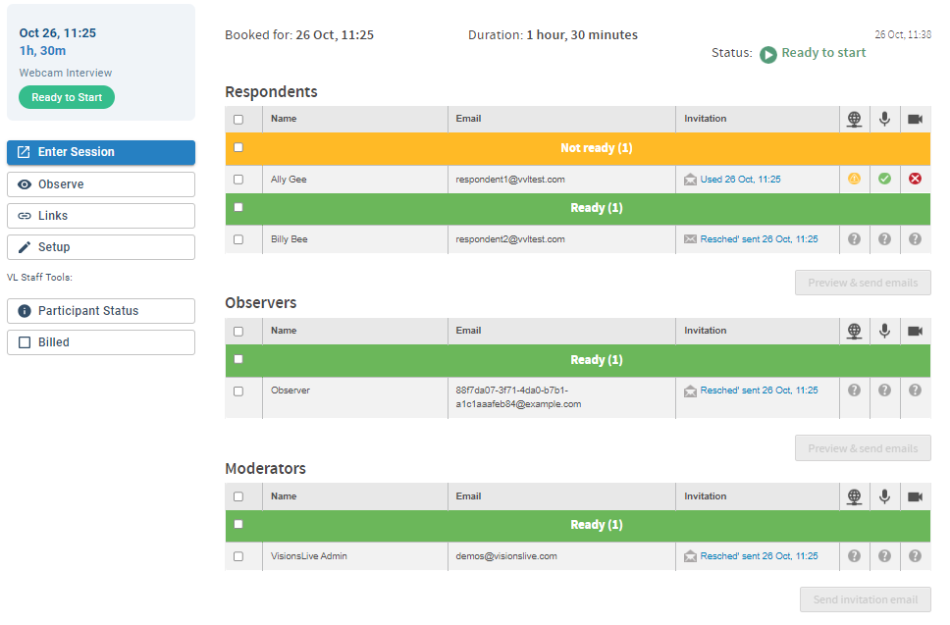The results of the checks are represented under Net, Audio, and Video columns, and use a traffic light system:

Red means that something has failed e.g. there is no camera on the device, or permissions were blocked to enable microphone access.

You can generally hover over the icon to find the associated error for these (e.g. NotAllowedError for permissions errors).

The result will also be red under ‘Net’ if a respondent tries to join from a mobile device when mobile access is disabled.

Yellow means that there is something to be aware of e.g. a slower internet speed, or ‘Net’ will show a yellow error if there has been a red warning for microphone or camera results.

Green means that the respondent has passed the System Check.

**Note:** System checks are great to help minimise potential tech problems, but passing this check doesn’t guarantee that there will be no tech problems at all during a session. These checks aren’t always able to pick up VPNs that may block access to the session room (as they’re designed to be untrackable), and it is not guaranteed that the respondent will join the session with the same device and same external conditions that they had when they completed the check.

## Setting up the Session Room

By clicking the ‘Enter Session’ button on the session’s dashboard, you will enter the interview or group’s session room. You can access this at any point once the session has been created to confirm settings and add any stimulus or activities.

### Session Settings

To change the settings of your session room, click on the ‘Cog’ icon on the far-right of the top toolbar. You can then click ‘Session Settings’ and this will give you a list of options to toggle on and off.

**Enable real-time voice transcriptions** – This allows you to turn the AI-generated captions on or off after the session has been created. If you turn this on, it will put a prompt on screen to remind you that extra charges will incur. You can click the link to review the cost before enabling them.

Once voice transcriptions are enabled, the platform will begin transcribing all spoken audio from the main audio channel, which can be seen as live-captions within the session, and can be accessed in the reports section after the session has been closed. To ensure the whole session is captured, voice transcriptions need to be turned on before the group or interview begins.

**Note**: By default, the spoken language that is detected will be the language you chose during the initial setup wizard. If you need to change the language, go back to ‘Setup’ on the activity’s dashboard, and edit the Spoken Language – this can be found under the ‘Schedule’ section.

**Allow mobile phone users into the room** – this is enabled by default but can be deselected to ensure only participants on laptop or desktop devices can enter the waiting/session room. Anyone that uses the incorrect device will be told to come back on a different device.

**Enable Translator Features –** This sets up a second audio channel for sessions that require simultaneous translation. This will be automatically enabled when a translator joins the session room if it isn’t already on.

**Privacy Settings** – These affect the ability for different participants to see the video feeds or assigned profile fields of each participant.

**Background blurring** – You can blur the background of all participants by toggling on the blur background button. Individual backgrounds can also be blurred by clicking on the ellipses on your profile icon.

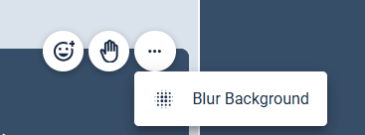

## Adding Stimulus

You can pre-load text prompts and image stimulus to your interviews or focus groups for the moderator to present during the session. You can do this at any point once the session is created, including whilst it is live if you have any last-minute adjustments.

To do so, start by navigating to the ‘Edit Stimulus’ tab on the top tool bar.

If you haven’t added any stimulus yet, click ‘Get Started’ to begin. 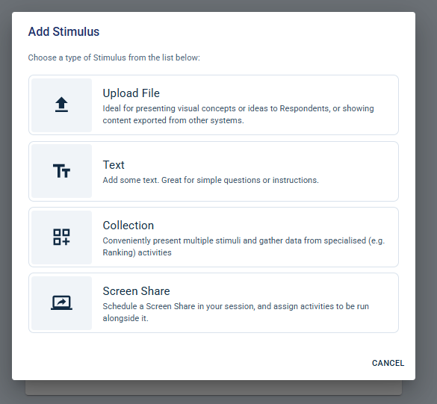

If you have some stim added in already, you will need to click on the ‘+’ icon at the top of the section, next to the word ‘Stimulus’.

This will open the Stimulus Editing area, where you can add two different types of stimuli: ‘Upload Image’ or ‘Text’.

Screen share – If you would like to run a text prompt poll or single/multi select poll whilst screen sharing, please select the screen share option during the set up and add a poll to this.

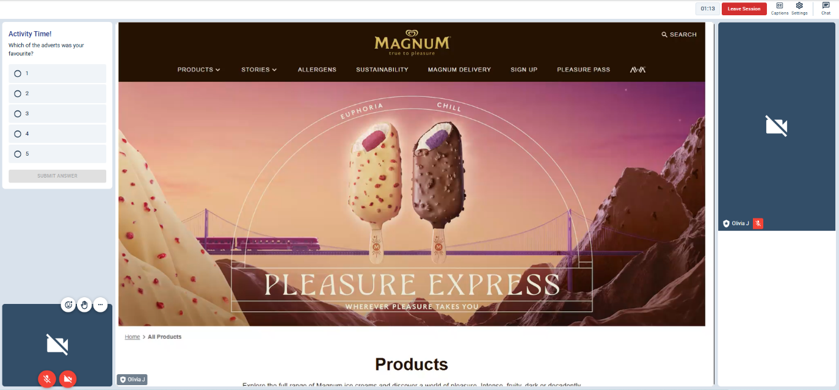

### Uploading Image Slides

Clicking on the “Upload File” button will open a window where you can upload your images by dragging a folder of images into it. You can also click ‘browse files’ to open your device’s file library and select the images you want to add.

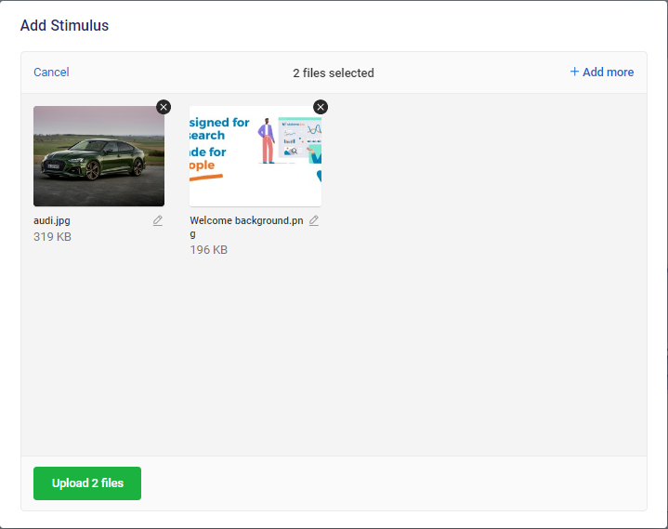Please ensure that any images uploaded are either in JPEG or PNG format.

Once selected, the images chosen will be shown in within the window.

If you wish to upload more images than initially selected, you may do so by clicking the “Add more” button on the top-right corner of the window.

You can then upload your images by clicking on the green “Upload” button at the bottom left corner of the window and wait for the encryption to be completed.

Each image will then represent a new slide in the stimulus list and will be denoted by an image icon. The stimulus can be easily moved around into your preferred order by clicking and dragging on the dots next to the stimulus’ titles.

By default, the slide titles will be the same as their file names when they were uploaded. If you would like to change these, click on the slide, and then click on the title above the image preview and type the new title. These titles won’t be visible to respondents.

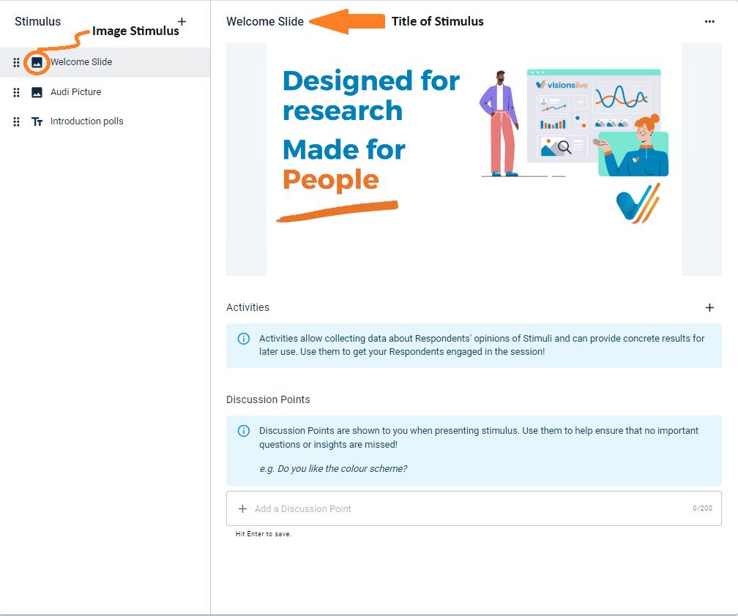

### Uploading Text Slides

Clicking on ‘Text’ on the above ‘Add Stimulus’ window will add a new blank text slide to your slide deck and can be identified by the accompanying 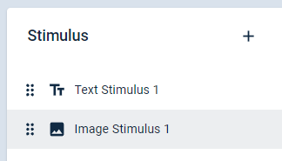 icon. This stimulus type will allow you to share plain text during the session to aid the discussion.

If you would like to change your text after it is initially created, you can click the pencil icon to edit it.

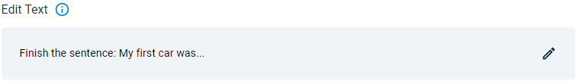

By default, the slide title will be ‘Untitled Text (#)’, with differing numbers depending on how many you have in your deck. If you would like to change these, click the title at the top of the selected Text item and type the new title. These titles won’t be visible to respondents.

The slide can be easily moved around into your preferred order by clicking and dragging on the dots next to the stimulus’ titles.

### Uploading Collections

Clicking on ‘Collections’ on the above ‘Add Stimulus’ window will add a new blank slide to your slide deck and can be identified by the accompanying  icon. This stimulus type will allow you to share a collection of images that participants can move through freely.

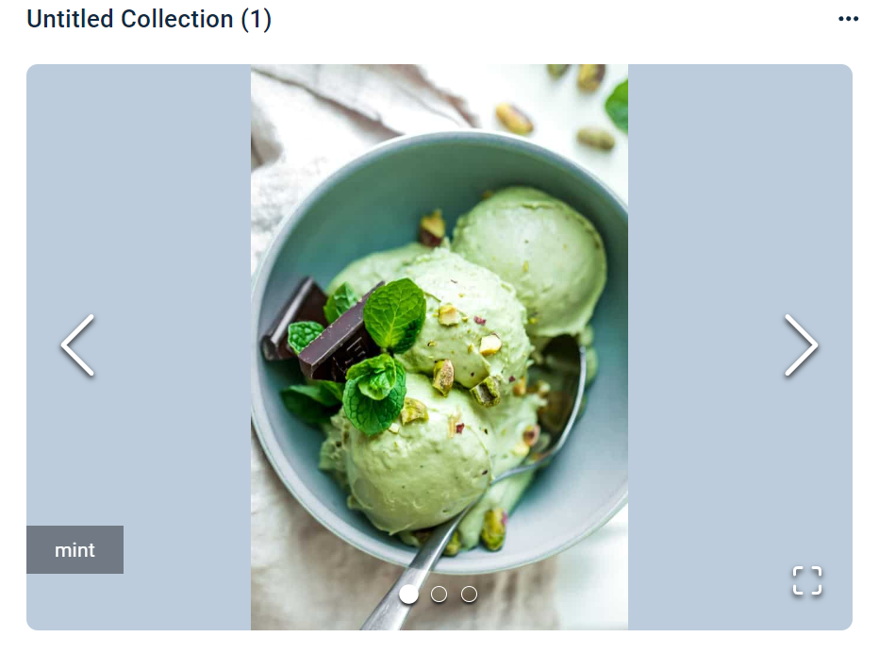Click on the ‘Add Stimulus’ button that appears to upload multiple images you would like to share during your group. After they have encoded, the images will appear in a collection with arrows either side to go through the different images.

If you wish to make any changes to your collection, this can be done underneath.

You can change the name of each image by hovering over the name and selecting the pencil icon. This will then let you edit the name.

You can also delete any images from the collection that you no longer want to show by clicking the bin icon on the right-hand side.

If you wish to anymore images to the collection, you can click ‘Add Stimulus’ at the bottom and add more to the collection.

By default, the collection title will be ‘Untitled Collection (#)’, with differing numbers depending on how many you have in your deck. If you would like to change these, click the title at the top of the selected Collection item and type the new title. These titles won’t be visible to respondents.

The slide can be easily moved around into your preferred order by clicking and dragging on the dots next to the stimulus’ titles.

You can add activities to a collection. To add an activity, please add your stimulus and then scroll down to the ‘+ADD ACTIVITY’ button. You will be presented with 3 poll options. Please see page 16 for more information on how to set up a poll.

### Deleting a Slide

To delete a slide from the deck, select the slide and then press the three dots in the top-right corner. This will give you the option to delete it.

### Changing the Slide Order

To adjust the order of the slides in the deck, click and hold the square dots icon ( ) to the left of the slide names. Then, drag the slide to the position you would like it to be.

## Adding Interactive Activities

Once you have added some text or image slides into your slide deck, you can create interactive activities. When the session is live, these can be used to get deeper insights from your respondents.

To add a new activity, navigate to the slide you want the activity assigned to.

Under the preview of your image or text stimulus, there will be an ‘Activities’ section title – click on the ‘+’ icon to the far-right. This will give you the choice of three activities: Poll, Heatmap, or Text Prompt.

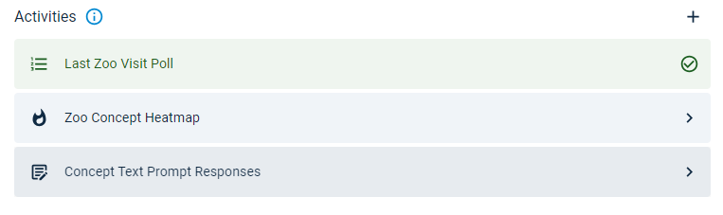

To add any of these to your slide, click the required option, and follow the steps for your choice below:

### Poll Activities

Single select and multiselect poll activities allow you to give respondents a question with set options that they can choose from.

After selecting this, click ‘Add Prompt’ to type or paste the question you would like respondents to answer.

You can then type the potential answers in the text box under ‘Poll Options’. To add an option, type the text for one answer, hit enter to save it, and repeat until you have added all your options.

### Ranking Poll Activities

Ranking Polls let you present respondents with a list of choices they can order by preference or importance. You can use this poll type alongside a piece of text or stimulus or attach it to a collection so respondents can rank the options linked to your images. (See page 14 for details on setting up a collection.)

After choosing this poll type, click “Add Prompt” to write or paste the question you want respondents to answer.

Next, enter the list of options you’d like them to rank. If the poll is linked to a collection, the options will be filled in automatically, matching the titles of your stimuli.

### Heatmap Activities

Heatmaps are only available for image stimuli. Selecting Heatmap allows you to start an activity where respondents can click on the image and add sentiment emojis and text responses to give you deeper insights. Respondents can also highlight stimuli and leave a pin to add sentiment to their markups.

First, click 'Add Prompt' to type or paste a prompt for your respondents to see alongside the image when the activity begins.

Next, choose the heatmap type. Selecting the 'pin' option will allow respondents to click on an image and leave a pin with a comment attached. Respondents will have the option to choose from up to five different pin types, ranging from very negative to very positive. However, as the moderator, you can change the pin titles and deselect certain pins, giving respondents fewer options to choose from.

The highlighter heatmap type allows respondents to draw on top of the stimuli to add their sentiment and comments. The sentiment the respondent chooses will determine the colour of the highlighter. For example, if a respondent highlights something they feel positively about, it will be shown in green. On the other hand, if a respondent highlights something they feel negatively about, the markup will show in red. Any neutral mark ups will be in yellow.

Note: If you are conducting an activity where the emojis are customised, the autogenerated sentiment marker will be based on what position the custom emoji was placed in during setup, not on the emoji itself.

##### Sentiment and Activity Options

After it is created, you have the option to customise the Sentiment and Activity Options that the respondents will see. You have the following customisation options:

* **Change the number of Sentiment Options:** Press the toggles to turn an option on/off.
* **Change the Option’s Title:** Hover over and click the title of the option you want to edit and type a new title.
* **Change the Option’s Emoji:** Hover over and click the emoji of the option you want to edit and choose a new emoji from the library that comes up.
* **Enable or Disable Comments:** Clicking the toggle under Activity Options allows you choose whether you would or wouldn’t like respondents to add comments alongside their sentiment choices.

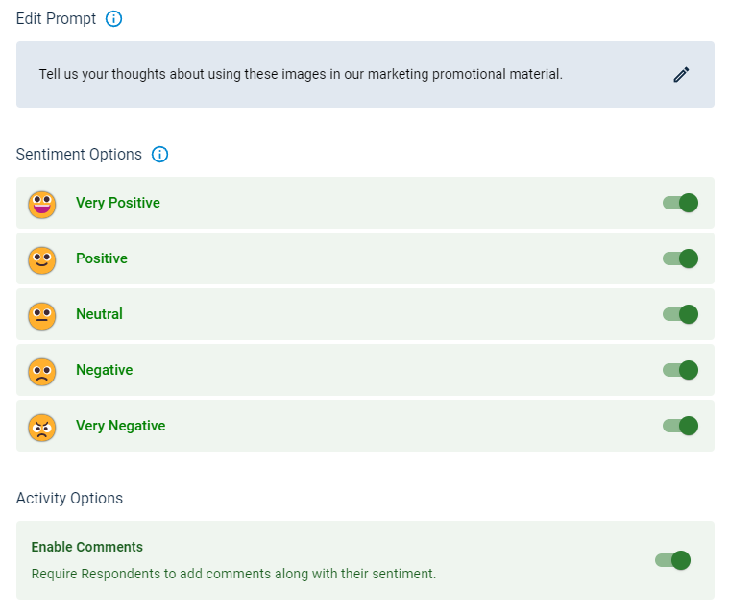

### Text Prompt Activities

Text prompt activities allow you to give respondents a prompt or question and a private text box for them to type their answer in.

To create this after selecting ‘Text Prompt’ as your activity, click on the pencil under ‘Add Prompt’. Then, type or paste the question or prompt you would like respondents to respond to in the text box that comes up.

### Activity Presentation Options

After an activity is run in a live session, the moderator will have the option to present the results to the session’s participants.

When you set up any activity, you can choose whether you want those responses to be anonymous or for the respondent names to be attached to their responses.

You can turn the anonymisation setting on or off by clicking the activity, and pressing the ‘Present Anonymised Results’ toggle under ‘Presentation Options’

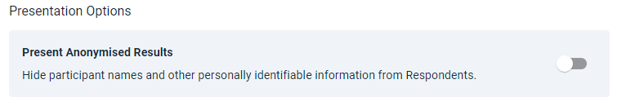

## Templates

If you are using the same content for several groups, you can save a template. This can be used to copy across stimulus, activities, and session settings from one group to any others within the same project.

### Saving a Template

Once you have finished loading your stimulus, activities, and session settings into one session, click the ‘Settings’ cog icon on the top-right of the page. Then, select ‘Save Template’.

This will give you the option to name and save your template.

### Applying a Template

To then apply it to other sessions in the project, you can do one of two things:

**When creating a new session:** When first setting up an activity, you can select the correct template from the dropdown on the first page of the setup wizard (‘Details’).

**To edit a currently existing session:** Go to the dashboard of the activity you would like to add the content to and select ‘Setup’ on the menu on the left. Then, click 'Edit' in the first section of the options that pop up.

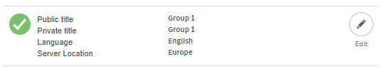

Then you can select the correct template from the dropdown.

