

Creating and Content-Loading
a Live Session
Prepared for:
Users of VisionsLive’s NEW Text Chat Focus Groups and Interviews

How to use this handbook:
This guide details how to set up a live Text Chat focus group or in-depth interview on VisionsLive from start to finish.
If you need information on something specific, you can find it using the table of contents below or by using CTRL+F to search for specific keywords.

Table of Contents
Content-loading your first focus group 3
Getting started 3
Creating your first Activity 4
The Waiting Room 7
Chat Areas 8
Preparing and running the session 10
Adding Stimulus 10
Uploading Image Slides 11
Uploading Text Slides 12
Uploading Collections 12
Adding Interactive Activities 13
Poll Activities 14
Ranking Poll Activities 14
Heatmap Activities 14
Sentiment and Activity Options 15
Text Prompt Activities 15
Templates 16
Predefined Probes 16
Ending a session 17
Reports 18

Content-loading your first focus group
This is a short guide on how to set up and run your first live session, and will include:
- The loading and preparation of stimulus, using all our interactive tools.
- How to make the most of the chat capabilities.
- How to save a template of your session room, to then copy across to other sessions within the same project.

Getting started
Log in at https://portalapp.visionslive.com – you should have received an email regarding setting up your login details. If you have not, contact support@visionslive.com. If you have forgotten your password, click on the “Forgotten your password?” link to be sent a new one.
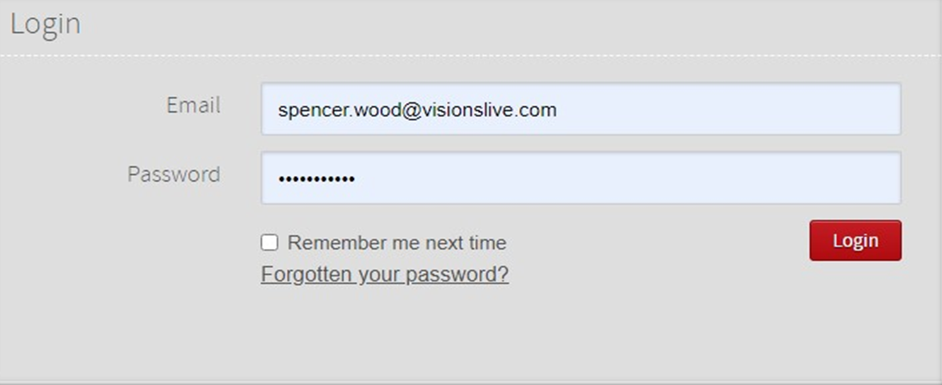
Once logged in, you will be taken to your company’s project dashboard. Here you will see a list of your projects, with the newest at the top and the oldest at the bottom. To create a new project, click on the “New Project” button in the top right of the screen.
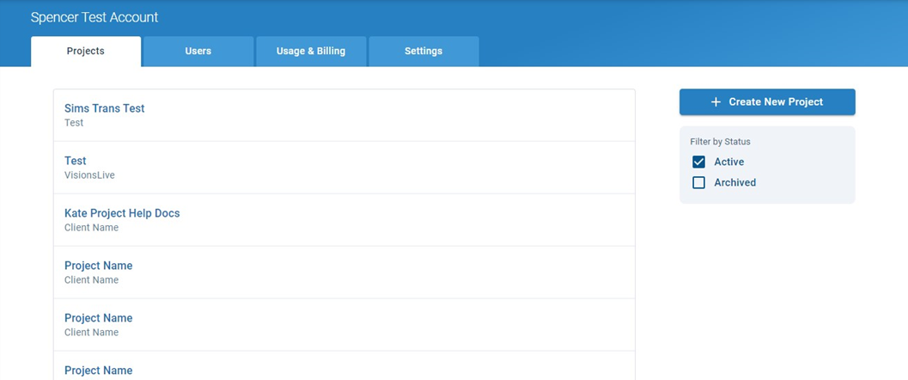
From here, enter your “Project Name” and “Client Name”. A description is not mandatory, and the language can be set at session-level if necessary, so does not need to be changed at this stage.
The “Sender Email Address” lets you know what email address your participants will get emails from if you send correspondence through the platform.
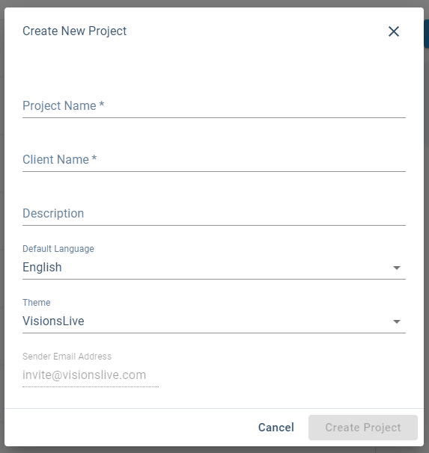

Creating your first Activity
Enter your project by clicking on it from the project dashboard. This will take you through to this project’s activity dashboard. This is where you will find all the activities created within a project, listed from top to bottom in the order of which they are due to run in. Click on the “Create New Activity” button in the top right corner to begin adding new activities.
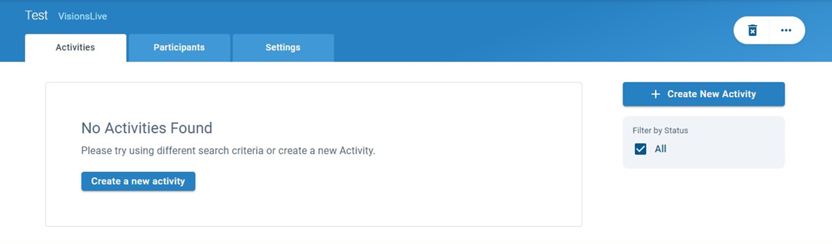
On the next page, choose the “New Text-chat” option under “New Focus Group”. This will take you through to creating the standard settings for your activity. You should find there are small question mark icons to provide you with information about specific settings.

Key Points:
    - Language – This dictates the default language setting within a session. This primarily affects the default language of the platform’s interface such as button text and platform prompt in recordings for video groups and interviews.
    - Participants will be prompted to select the language they would each like to see the platform in when they join, rather than seeing the default language.
    - Server Location – There are 5 servers to choose from – it is recommended to choose the server closest to your respondents.
    - Template – Useful if you are using the same content for several groups. When done loading the content into your first activity you may save it as a template. When creating your next group, you will find this template in the “Copy Content From” drop-down ready for you to select. This will copy of the previously loaded content across to your new group, saving you the trouble of re-uploading it.
    - Schedule – When scheduling your group, ensure whichever time and date you have chosen corresponds correctly with the time-zone selected in the drop-down above. Whilst the text of the time-zone does not change in correlation with seasonal time changes, the platform does recognise when a time-zone has gone back or moved forward an hour.
    - Estimated Duration – The expected time a session will last, however a session will only end when you choose to manually end it so you can be flexible. The times can be shifted up and down and our pricing system is based on 15-minute blocks to ensure you are not over-paying for your true usage. We also allow a 3-minute grace period every 15 minutes, to allow you to say your goodbyes and close-down the session without having to rush it.
    - Breakout Rooms – Up to 3 Breakout Rooms can be added to a session to allow you to split up respondents into separate rooms. Please ask your VisionsLive Project Coordinator if you would like breakout rooms included in your session.
    - Adding Participants – If copying respondents and observers across from an excel spreadsheet, please ensure you have included a field for their first name and email address. Last names are always recommended in order to ensure differentiation between respondents who may have the same first name but is not compulsory. Custom fields may be included if you wish to view specific criteria about your respondents during the session.
    - All participants must be uploaded in batches dependent on their time-zone (this ensures that they are sent the correct time dependent on their location when sending their invitation).
    - Dummy emails can be used at this stage for confidentiality, and individual participation links extracted later.
    - Adding Moderators – This will show a list of all moderators added to your company account. To add a new moderator, they must first be added to your company account as a user.
    - Email/SMS – The “Availability” email asks respondents if they are available when the group is scheduled to take part. If they answer “Yes” they will be sent an email invitation; if they answer “No”, or do not respond, they will not be sent an email invitation.
    - The SMS reminder allows you to send a customisable reminder to the respondents via text message, between 15 minutes – 4 hours before the session is due to begin. There is a small charge per SMS.
    - Invitation Emails – These have a standard English template, but it can be edited almost completely.
    - The {ActivityAccessLink} must remain as this generates each individual’s link to join the session.
    - The {ActivityStartTime} tag is also very useful as this adapts the start time of the session to be specific to the receiving individual’s local time zone.

Entering the session room
Once you have added and confirmed yourself as a moderator during the setup of an activity, you will receive an automatic invitation with a link to the session room. However, you can also enter the session room directly through the platform. To do this, click on the activity and then, on your “Session Dashboard” page, click on the blue “Enter Session” button on the left to enter.
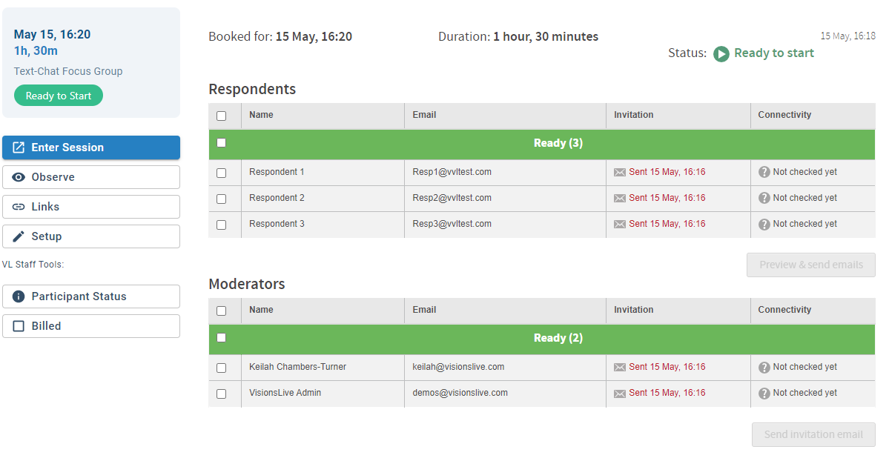

The Waiting Room
When a respondent or observer clicks on their link to join the session, they will first enter the Waiting Room. As the moderator, you can enter the Waiting Room by clicking on the “Waiting Room” button in the top left corner of the actual session room and then clicking “Go To Waiting Room”.
A red notification will pop up on this button whenever there is at least one respondent or observer present within. The waiting room can be used to speak to and filter through respondents and observers, prior to the group commencing.
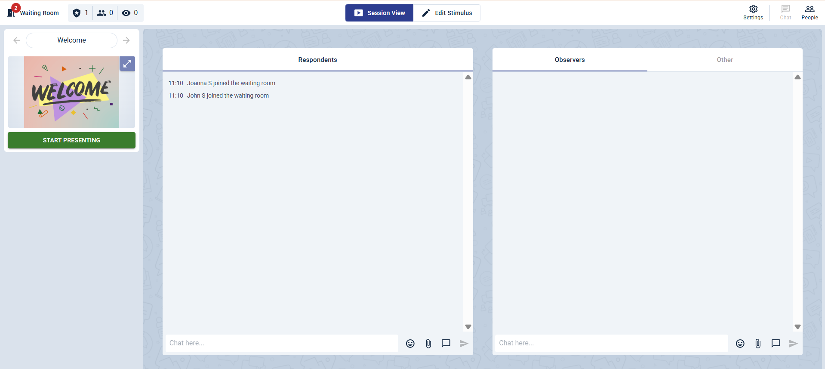
When you enter the room, you will notice a chat space on the right-hand side which you can use to send messages to the group as they wait. You can also click on an individual’s “Message” button to send them a message privately. If you do this and would later like to return to the group chat, click on the “Chat To All” tab in the top right corner.
Click the checkbox next to the names of the respondents you would like to invite in and then press “Invite”, or head back to the session room, click on the “Waiting Room” button and then press “Invite All”.
Once you bring your first respondent into the main session room, you will begin being charged for your session and the timer will start ticking in the top-right hand side of the screen.
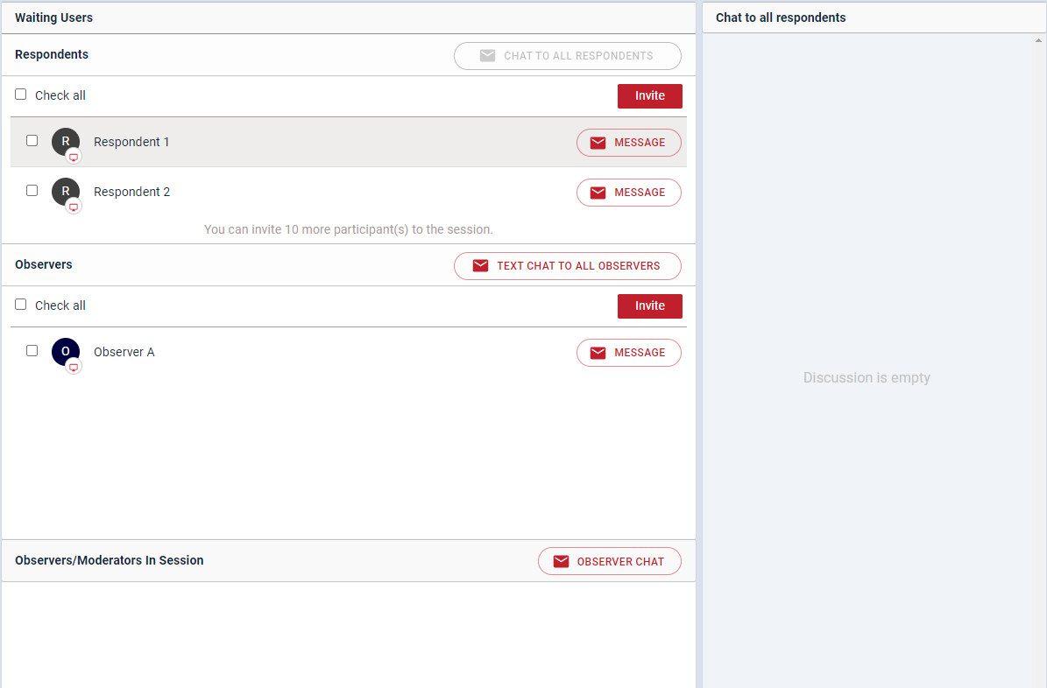

Chat Areas
The chat area is situated at the right of your screen and can be viewed by clicking on the text box icon in the top right-hand corner.
By default, this will open 3 chat panels: the observer chat, and the respondent chat and ‘other’. You can pin the chat area open by clicking on the ‘keep open’ button.
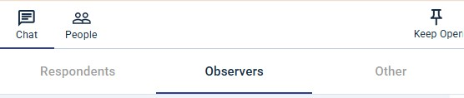

Observer Chat
The Observer Chat is where observers and moderators can talk to each other throughout the session. This chat is private and cannot be seen by respondents.
This panel also notifies moderators when observers join or leave the waiting room before the session, or the session room once it has started.
The messages sent by moderators have a gold hue to them for easy identification.

Respondent Chat
The respondent chat is where respondents can message each other and the moderator(s).
Observers cannot type in this chat but can read it.
Like the Observer Chat, this chat area indicates when respondents enter the waiting room, are invited to the session from the waiting room and when they leave.
The Respondent Chat also includes the unique colours and names of each participant alongside their messages.
Other
In this area, moderators can create group chats and view private messages.

Private Chats
Moderators can create private chats with any participant in the session room. To do this, click on the three dots next to a person’s name on their camera tile or in the ‘Show Participants List’ section and select “Private Message”. The new chat can be found in the ‘Other’ panel.
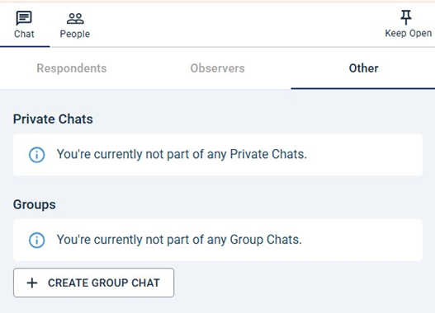

Group Chats
You can also create group chats between yourself and any participants. This includes VL Admin, and the translator. This is done by “Create Group Chat”.
Note: Anyone can be added to a group chat, but observers and respondents cannot be added to the same chat as each other to avoid
The group chat will need to be titled before adding the participants to create it.

Moving between chats
It is easy to move between chats. Simply click on the chat heading you wish to move to. To close a chat, click outside of the chat area and into the main session room. You can pin a chat open by clicking on ‘keep open’.

Notifications
A notification in the form of a jumping red circle will be shown on top of the textbox at the top right corner of the screen when there are any new messages or notifications in the chat areas. The circle has a number indicating the number of new messages.
Clicking the icon will open the chat panels where the new messages will be shown. If the chat panels with the new messages are hidden from view but the chat area is open, the notification will be in the form of a red flashing circle at the top of each chat panel. Clicking that circle will show the name of the chat and the number of unread messages.

Chat Tools
- The chat areas include a range of useful tools found at the bottom of each panel.
- Text box: Type messages to other participants by typing in the “Chat here…” space.
- Emojis: To the right of the space, there is a smiley face denoting some easy access emojis that can be used by all participants.
- Attachments: Moderators can send attachments using the paperclip symbol; however, observers and respondents do not have this option.

Preparing and running the session
Upon entering the session room for the first time you will observe the room in it’s default chat layout. This provides you with a large chat area in the centre of the screen with the “Observer Chat” the “Respondent Chat” and “Other”.
Respondents cannot see the Observer Chat so instead their view consists of an extended Respondent Chat.

Adding Stimulus
You can pre-load text prompts and image stimulus to your interviews or focus groups for the moderator to present during the session. You can do this at any point once the session is created, including whilst it is live if you have any last-minute adjustments.
To do so, start by navigating to the ‘Edit Stimulus’ tab on the top tool bar. If you haven’t added any stimulus yet, click ‘Get Started’ to begin. 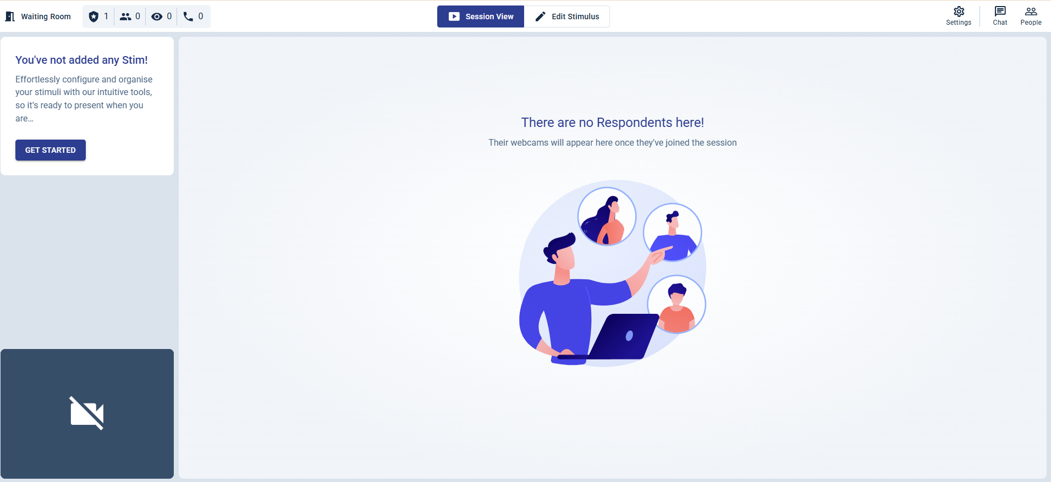

If you have some stim added in already, you will need to click on the ‘+’ icon at the top of the section, next to the word ‘Stimulus’.
This will open the Stimulus Editing area, where you can add two different types of stimuli: ‘Upload Image’ or ‘Text’.

Uploading Image Slides
Clicking on the “Upload File” button will open a window where you can upload your images by dragging a folder of images into it. You can also click ‘browse files’ to open your device’s file library and select the images you want to add.
Please ensure that any images uploaded are either in JPEG, PNG format or PowerPoint format.
Once selected, the images chosen will be shown in within the window.
If you wish to upload more images than initially selected, you may do so by clicking the “Add more” button on the top-right corner of the window.
You can then upload your images by clicking on the green “Upload” button at the bottom left corner of the window and wait for the encryption to be completed.
Each image will then represent a new slide in the stimulus list and will be denoted by an image icon. The stimulus can be easily moved around into your preferred order by clicking and dragging on the dots next to the stimulus’ titles.
By default, the slide titles will be the same as their file names when they were uploaded. If you would like to change these, click on the slide, and then click on the title above the image preview and type the new title. These titles won’t be visible to respondents.
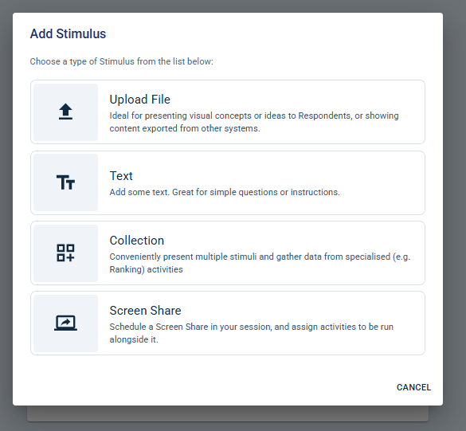

Uploading Text Slides
Clicking on ‘Text’ on the above ‘Add Stimulus’ window will add a new blank text slide to your slide deck and can be identified by the accompanying icon. This stimulus type will allow you to share plain text during the session to aid the discussion.
If you would like to change your text after it is initially created, you can click the pencil icon to edit it.
By default, the slide title will be ‘Untitled Text (#)’, with differing numbers depending on how many you have in your deck. If you would like to change these, click the title at the top of the selected Text item and type the new title. These titles won’t be visible to respondents.
The slide can be easily moved around into your preferred order by clicking and dragging on the dots next to the stimulus’ titles.

Uploading Collections
Clicking on ‘Collections’ on the above ‘Add Stimulus’ window will add a new blank slide to your slide deck and can be identified by the accompanying icon. This stimulus type will allow you to share a collection of images that participants can move through freely.
Click on the ‘Add Stimulus’ button that appears to upload multiple images you would like to share during your group. After they have encoded, the images will appear in a collection with arrows either side to go through the different images.
If you wish to make any changes to your collection, this can be done underneath.
You can change the name of each image by hovering over the name and selecting the pencil icon. This will then let you edit the name.
You can also delete any images from the collection that you no longer want to show by clicking the bin icon on the right-hand side.
If you wish to anymore images to the collection, you can click ‘Add Stimulus’ at the bottom and add more to the collection.
By default, the collection title will be ‘Untitled Collection (#)’, with differing numbers depending on how many you have in your deck. If you would like to change these, click the title at the top of the selected Collection item and type the new title. These titles won’t be visible to respondents.
The slide can be easily moved around into your preferred order by clicking and dragging on the dots next to the stimulus’ titles.
You can add activities to a collection. To add an activity, please add your stimulus and then scroll down to the ‘+ADD ACTIVITY’ button. You will be presented with 3 poll options. Please see page 16 for more information on how to set up a poll.

Deleting a Slide
To delete a slide from the deck, select the slide and then press the three dots in the top-right corner. This will give you the option to delete it.

Changing the Slide Order
To adjust the order of the slides in the deck, click and hold the square dots icon ( ) to the left of the slide names. Then, drag the slide to the position you would like it to be.

Adding Interactive Activities
Once you have added some text or image slides into your slide deck, you can create interactive activities. When the session is live, these can be used to get deeper insights from your respondents.
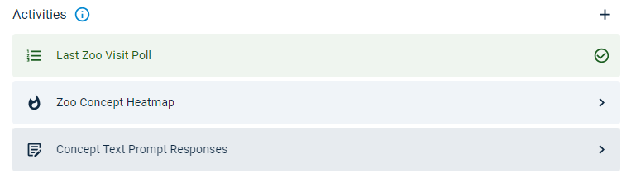
To add a new activity, navigate to the slide you want the activity assigned to.
Under the preview of your image or text stimulus, there will be an ‘Activities’ section title – click on the ‘+’ icon to the far-right. This will give you the choice of three activities: Poll, Heatmap, or Text Prompt.
To add any of these to your slide, click the required option, and follow the steps for your choice below.

Poll Activities
Single select and multiselect poll activities allow you to give respondents a question with set options that they can choose from.
After selecting this, click ‘Add Prompt’ to type or paste the question you would like respondents to answer.
You can then type the potential answers in the text box under ‘Poll Options’. To add an option, type the text for one answer, hit enter to save it, and repeat until you have added all your options.

Ranking Poll Activities
Ranking Polls let you present respondents with a list of choices they can order by preference or importance. You can use this poll type alongside a piece of text or stimulus or attach it to a collection so respondents can rank the options linked to your images. (See page 14 for details on setting up a collection.)
After choosing this poll type, click “Add Prompt” to write or paste the question you want respondents to answer.
Next, enter the list of options you’d like them to rank. If the poll is linked to a collection, the options will be filled in automatically, matching the titles of your stimuli.

Heatmap Activities
Heatmaps are only available for image stimuli. Selecting Heatmap allows you to start an activity where respondents can click on the image and add sentiment emojis and text responses to give you deeper insights. Respondents can also highlight stimuli and leave a pin to add sentiment to their markups.
First, click 'Add Prompt' to type or paste a prompt for your respondents to see alongside the image when the activity begins.
Next, choose the heatmap type. Selecting the 'pin' option will allow respondents to click on an image and leave a pin with a comment attached. Respondents will have the option to choose from up to five different pin types, ranging from very negative to very positive. However, as the moderator, you can change the pin titles and deselect certain pins, giving respondents fewer options to choose from.
The highlighter heatmap type allows respondents to draw on top of the stimuli to add their sentiment and comments. The sentiment the respondent chooses will determine the colour of the highlighter. For example, if a respondent highlights something they feel positively about, it will be shown in green. On the other hand, if a respondent highlights something they feel negatively about, the markup will show in red. Any neutral mark ups will be in yellow.
Note: If you are conducting an activity where the emojis are customised, the autogenerated sentiment marker will be based on what position the custom emoji was placed in during setup, not on the emoji itself.

Sentiment and Activity Options
After it is created, you have the option to customise the Sentiment and Activity Options that the respondents will see. You have the following customisation options:
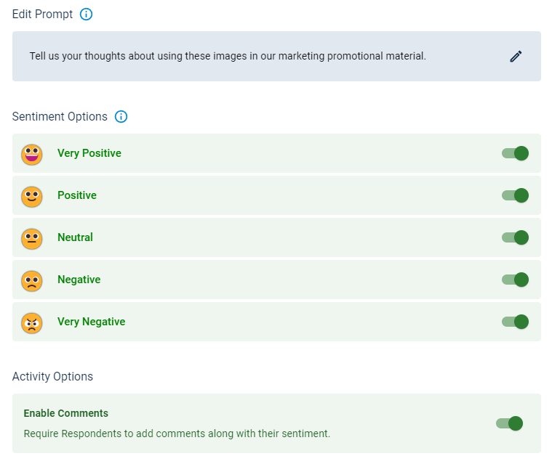
Change the number of Sentiment Options: Press the toggles to turn an option on/off.
Change the Option’s Title: Hover over and click the title of the option you want to edit and type a new title.
Change the Option’s Emoji: Hover over and click the emoji of the option you want to edit and choose a new emoji from the library that comes up.
Enable or Disable Comments: Clicking the toggle under Activity Options allows you choose whether you would or wouldn’t like respondents to add comments alongside their sentiment choices.

Text Prompt Activities
Text prompt activities allow you to give respondents a prompt or question and a private text box for them to type their answer in.
To create this after selecting ‘Text Prompt’ as your activity, click on the pencil under ‘Add Prompt’. Then, type or paste the question or prompt you would like respondents to respond to in the text box that comes up.

Activity Presentation Options
After an activity is run in a live session, the moderator will have the option to present the results to the session’s participants.
When you set up any activity, you can choose whether you want those responses to be anonymous or for the respondent names to be attached to their responses.
You can turn the anonymisation setting on or off by clicking the activity and pressing the ‘Present Anonymised Results’ toggle under ‘Presentation Options’.
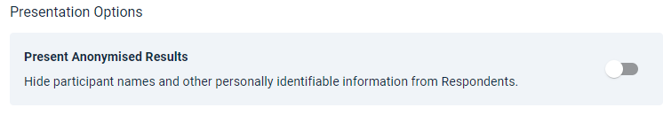

Templates
If you are using the same content for several groups, you can save a template. This can be used to copy across stimulus, activities, and session settings from one group to any others within the same project.

Saving a Template
Once you have finished loading your stimulus, activities, and session settings into one session, click the ‘Settings’ cog icon on the top-right of the page. Then, select ‘Save Template’.
This will give you the option to name and save your template.

Applying a Template
To then apply it to other sessions in the project, you can do one of two things:
When creating a new session: When first setting up an activity, you can select the correct template from the dropdown on the first page of the setup wizard (‘Details’).
To edit a currently existing session: Go to the dashboard of the activity you would like to add the content to and select ‘Setup’ on the menu on the left. Then, click 'Edit' in the first section of the options that pop up.
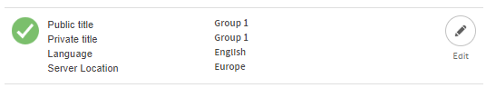
Then you can select the correct template from the dropdown.

Predefined Probes and Discussion Guide
Predefined probes allow you to store common phrases and questions within the platform, that can be quickly accessed during chat conversations.
Like the discussion guide feature, these probes can be added to the platform ahead of time. They can be accessed within the chat areas, and when pressed, will quickly add your chosen phrases to the text box. This will allow you to save time typing you may write a lot, such as follow up questions and activity instructions.
Probes are unique to each moderator i.e. if you have more than one moderator in a project, they can all have their own individual probe bank with different probes to each other.
To access probes, click on the speech bubble icon in the chat area. This will open a pop up called ‘Predefined Probes’. At this point, you can click on any probes that are in the bank already.
Probes can be hovered over to see what the full message would be, and when a probe is clicked on, the full message is automatically added to the text box of the chat area you are in.
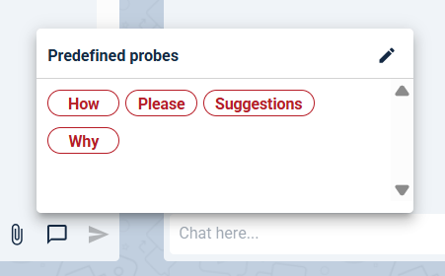
If you would like to add new probes, or edit pre-existing ones, click the pencil icon on the top right of the predefined probes pop-out (see screenshot above).
This will then give you a text box to write in that will create your probes. To create a new probe, you need to add a line of text that includes the probe’s label, an equal’s sign ‘=’, and what it represents.
E.g: Why = Why do you think that?
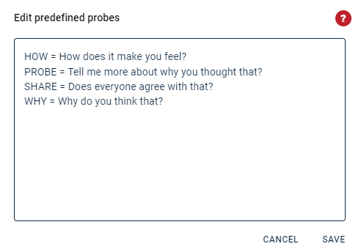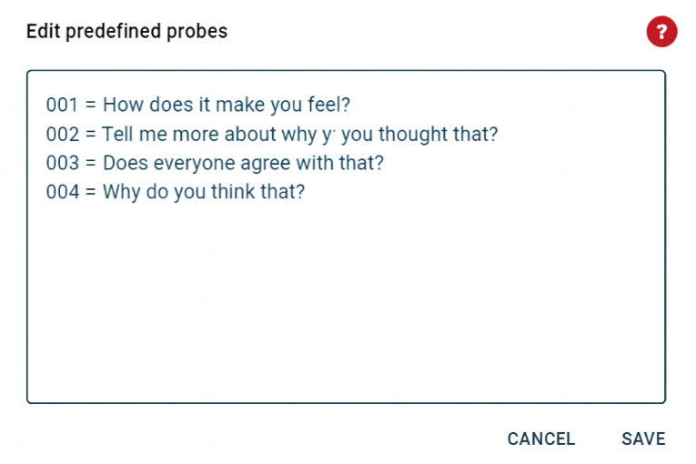
This will then give you a probe like the one in the initial screenshot above, where ‘Why’ is the label, and ‘Why do you think that?’ is the message that will be added to the chat area.
The predefined probe bank can also be used as your discussion guide, following the same numbering format. If you have up to 99 questions, we recommend numbering them as 01 for Question 1, 02 for Question 2, and so on, up to 99 for Question 99.
If you have more than 99 questions, we suggest using a three-digit format—001 for Question 1, 002 for Question 2, continuing through 100 for Question 100, 101 for Question 101, and so forth.
This system ensures that questions load into the probe bank in chronological order, helping you keep everything organised and correctly sequenced.

Ending a session
There are now two options for ending a session, and it’s important to choose the one that suits your needs:
- To end the session for everyone on the call: Click on ‘End Session’, then click ‘End Session’ again. This will remove all participants from the session and stop any further charges for the session.
- To end the session for respondents while still chatting with your observers: Click on ‘End Session’ and then check the box that says, ‘Start an Observer Wrap-Up’. After that, click ‘End Session’. This will activate the Observer Debrief Channel for all moderators and observers. The Observer Debrief is free of charge.

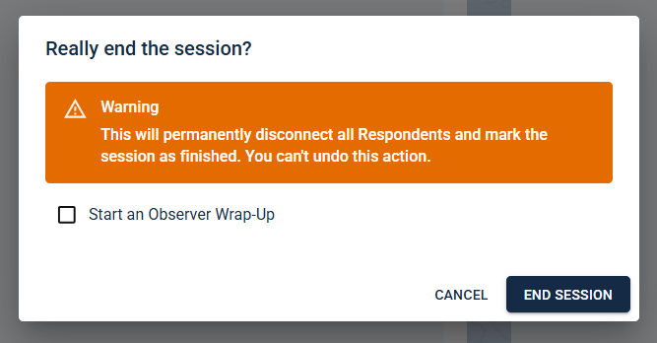

Reports
Once your session has ended you will then have access to your Session Reports page. You can find this by going into your Project dashboard and clicking the “View reports” button that will appear when the session is completed.
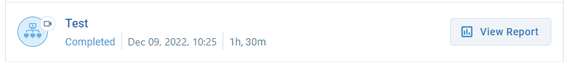

Participation/Chat
The first tab on the reports page is the “participation/chat” tab. In this tab you will be able to see any communication from the chat boxes throughout your session. The respondent chat will be shown on the left and the observer chat on the right. You can download the contents of the chat by clicking the download icon at the top right of the respondent chat.
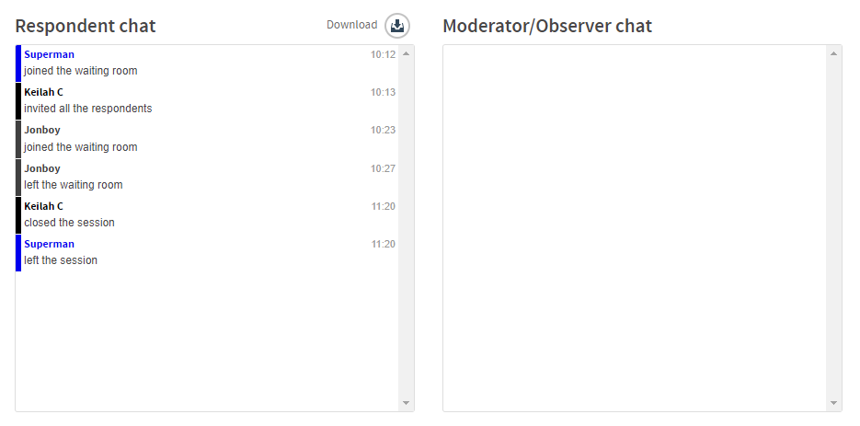
Below this you will find a grid with the names of all the session’s participants. This grid shows you which participants joined the session and when, their role in the session and whether they participated in any activities or chat boxes by showing a tick or a cross in the last column.
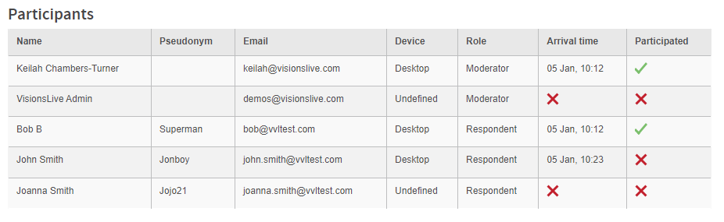

Activity Results
The Activity Results page of the reports will show you the results of any interactive activities you have run during the interview or group. The polls, heatmaps, and text prompt questions associated with each slide will show up under the name of each piece of stimulus. This page gives a quick overview of sentiment from your heatmap activities, to make it easy to compare different pieces of stimulus. Click on the ‘Explore Results’ button on the activity you would like to see more detailed responses for, and it will show you the answers in the centre of the screen. Polls If you click on ‘Explore Results’ for a poll, it will bring up the results in the centre of the screen.
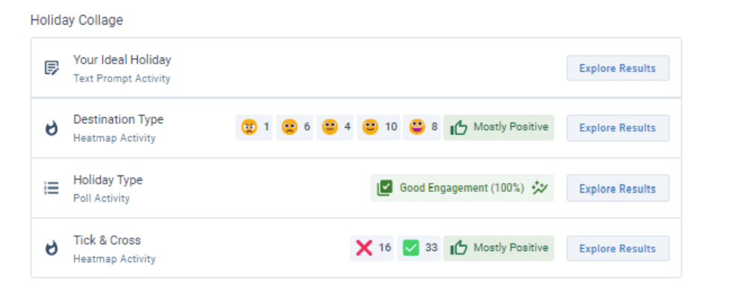
You will see the results ordered with the option with the highest number of votes at the top, and the lowest at the bottom. In addition, the first-place response will have a gold trophy and outline, second place will have silver, and third place will have bronze. If you click on a specific option, you will be able to see the names of the respondents who chose that option.
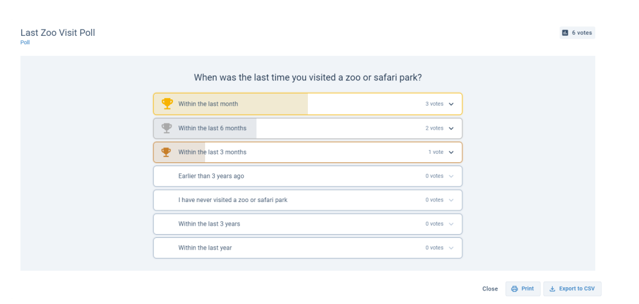
Exporting: There are two options to export your results – Print: To save the poll as a PDF file, select the ‘Print’ button and a pop-up will show. On this page, ensure the ‘Destination’ is set as ‘Save as PDF’, and then click ‘Save. Alternatively, select a printer as the destination, and you can print the results directly. Export to CSV: This will export your data in a table in a CSV formatted document.
Heatmaps If you click on ‘Explore Results’ for a heatmap, it will bring up the results in the centre of the screen. This shows you the stimuli that was used, and all the markups that respondents left on the image depending on whether they dropped pins or used the highlight options. Each markup is numbered, and if comments were enabled, the number will correspond with the comments listed underneath the image. In the top-right corner, there is an overview of the responses given and an automatically generated marker showing the general sentiment of the activity.
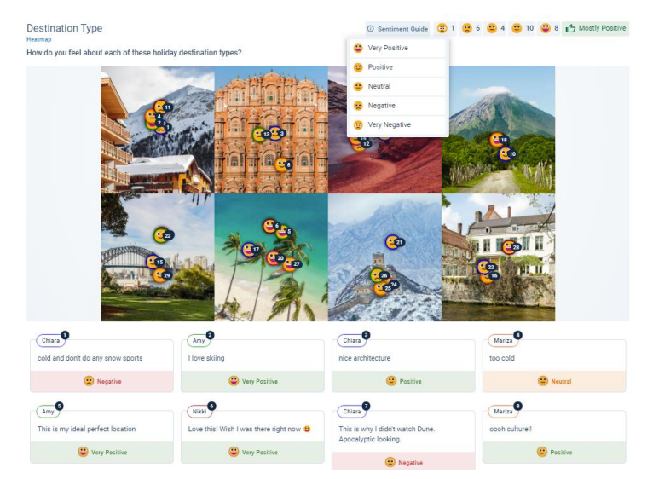
This can also be seen on the ‘Activity Results’ tab. This is useful to quickly compare different heatmaps showing various concepts. You can also hover over the ‘Sentiment Guide’ label to check what each emoji represents in the exercise. 6 Note: If you are conducting an activity where the emojis are customised, the autogenerated sentiment marker based on what position the custom emoji was placed in during setup, not on the emoji itself. For example, in the tick-cross exercise below, the ‘Very Positive’ sentiment was replaced with the tick emoji, and the ‘Very Negative’ one was replaced by the cross emoji (and the others were disabled). If the emojis had been placed the opposite way around, the results would say ‘Mostly Negative’ despite it having a lot of ticks. This is important to note and check if your generated results do not seem accurate.
Exporting: If you would like to export these results as a PDF, click on the ‘Print’ button on the bottom right, choose ‘Save as PDF’ as the Destination when prompted, and then click ‘Save’.
Text Prompts If you have click on ‘Explore Results’ for a Text Prompt activity, it will bring up the results in the centre of the screen.
Exporting: If you would like to export these results as a PDF, click on the ‘Print’ button on the bottom right, choose ‘Save as PDF’ as the Destination when prompted.
